# **<Application Name> – PT Workbook Findings**

# Information Gathering:

## Search Engine Discovery or Reconnaissance:

Tried to Search for the site, sensitive files, and documents in public domain search like Google, Microsoft Bing & Yahoo

* **Search for the site, sensitive files, documents in Google.com-**

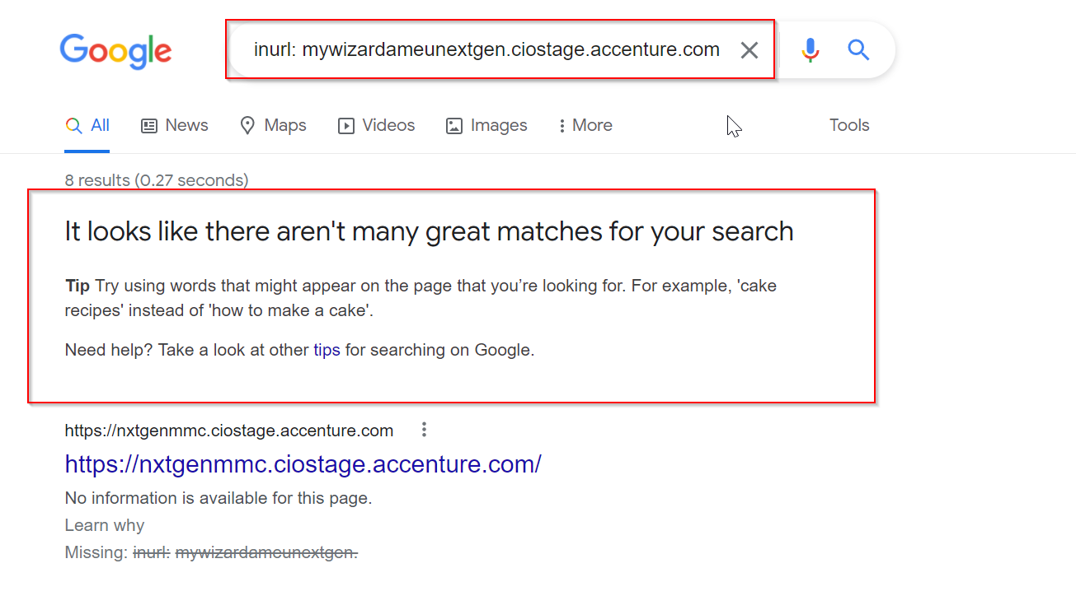

In result Sensitive Information has not been disclosed.

* **Search for the site, sensitive files, documents in Microsoft Bing –**

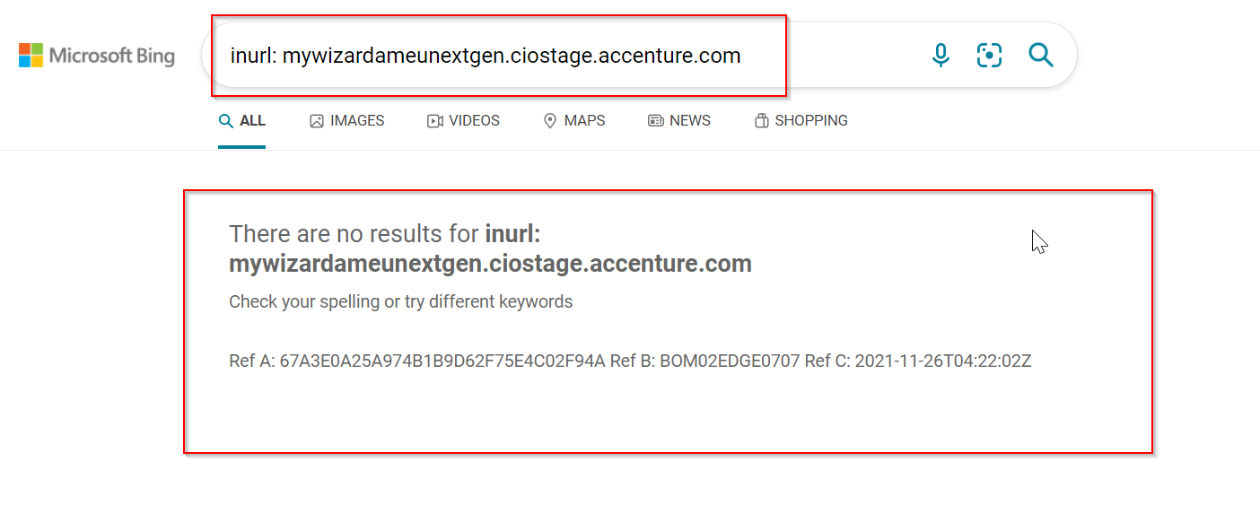

In result Sensitive Information has not been disclosed.

* **Search for the site, sensitive files, documents on Yahoo.com -**

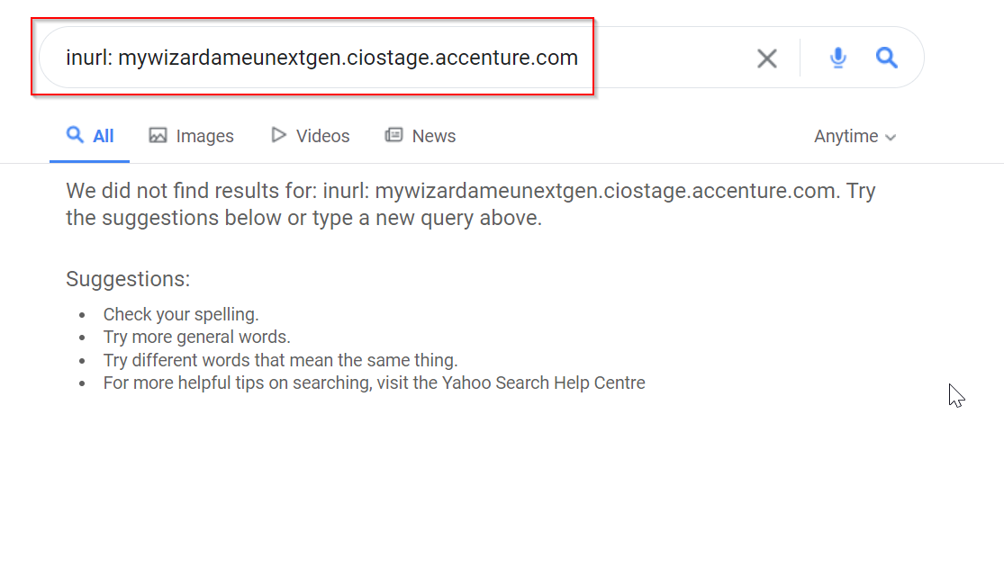

In result Sensitive Information has not been disclosed.

Filetype:

* **Search for the site, sensitive files, documents on Google.com –**

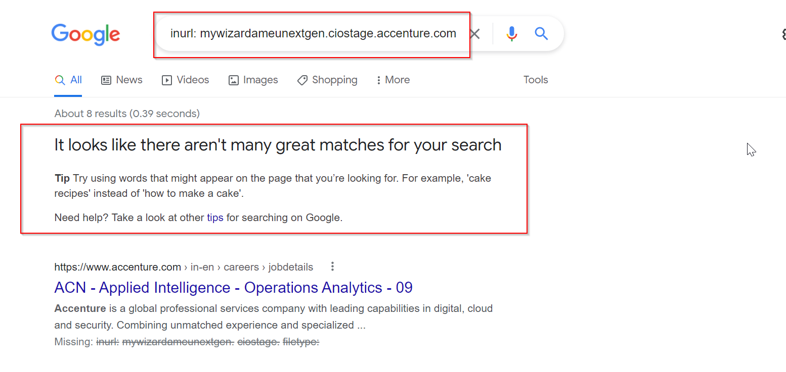

In result Sensitive Information has not been disclosed.

* **Search for the site, sensitive files, documents in Microsoft Bing -**

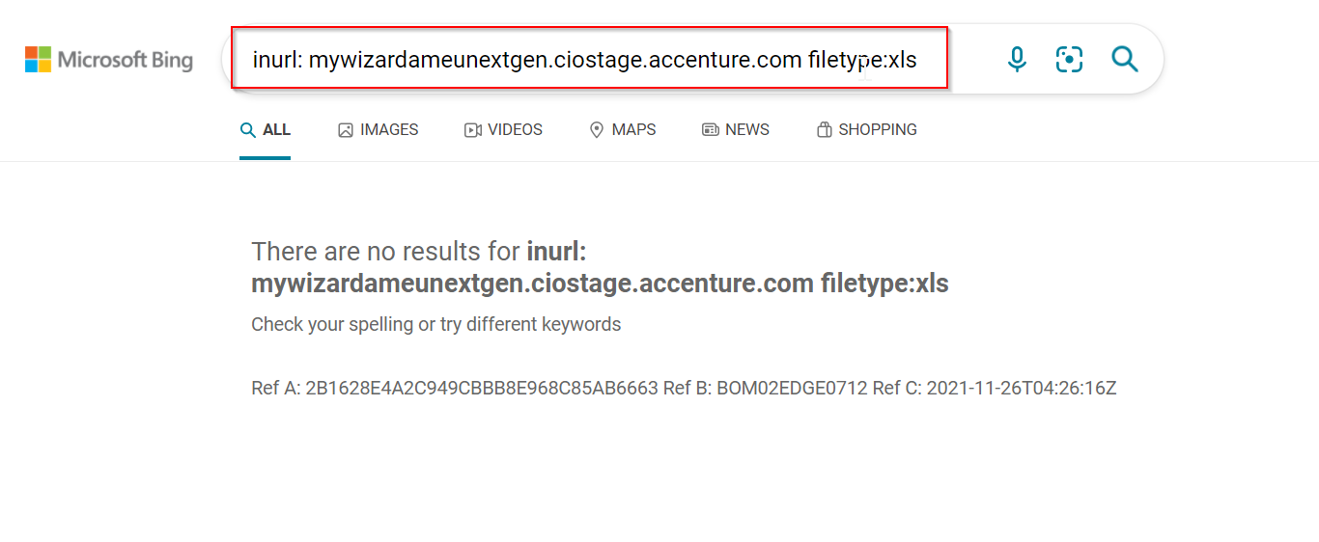

In result Sensitive Information has not been disclosed.

* **Search for the site, sensitive files, documents on Yahoo.com -**

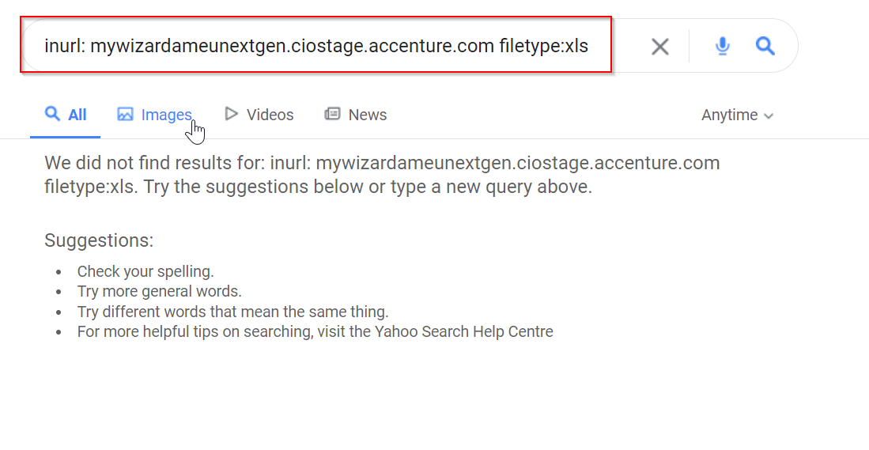

In result Sensitive Information has not been disclosed.

Shodan check:

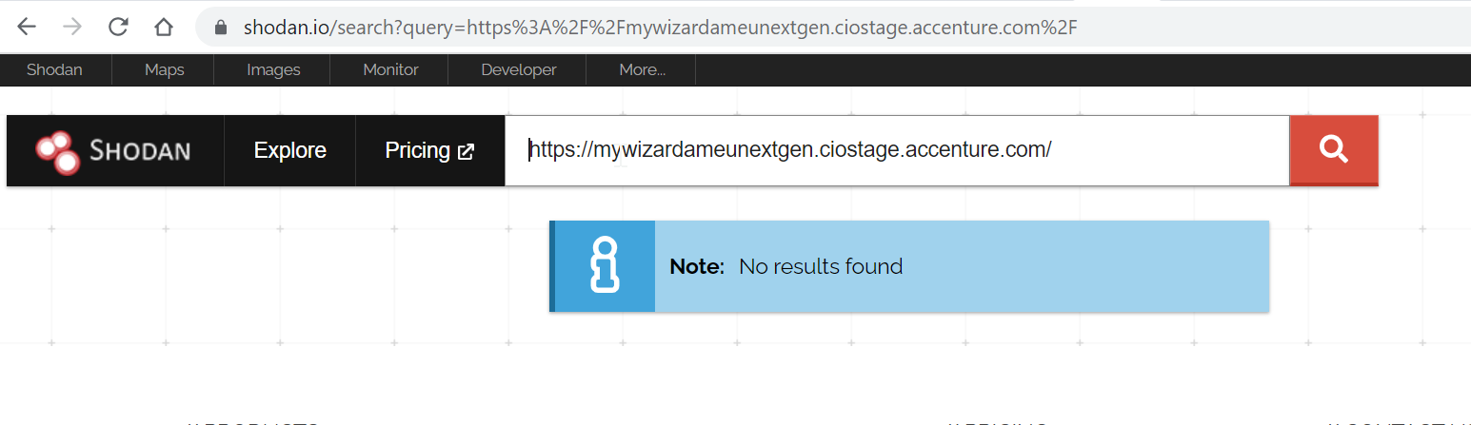

No result found during the test.

Dnsdumpster:

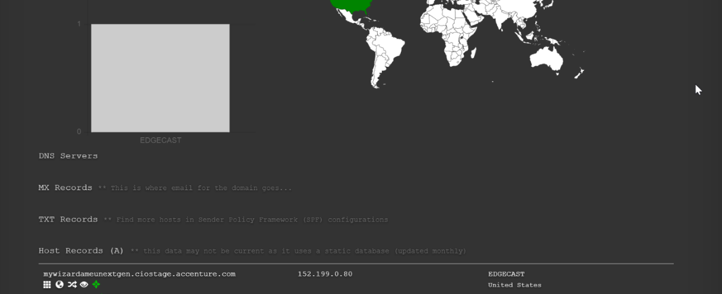

## Analysis of Error Codes:

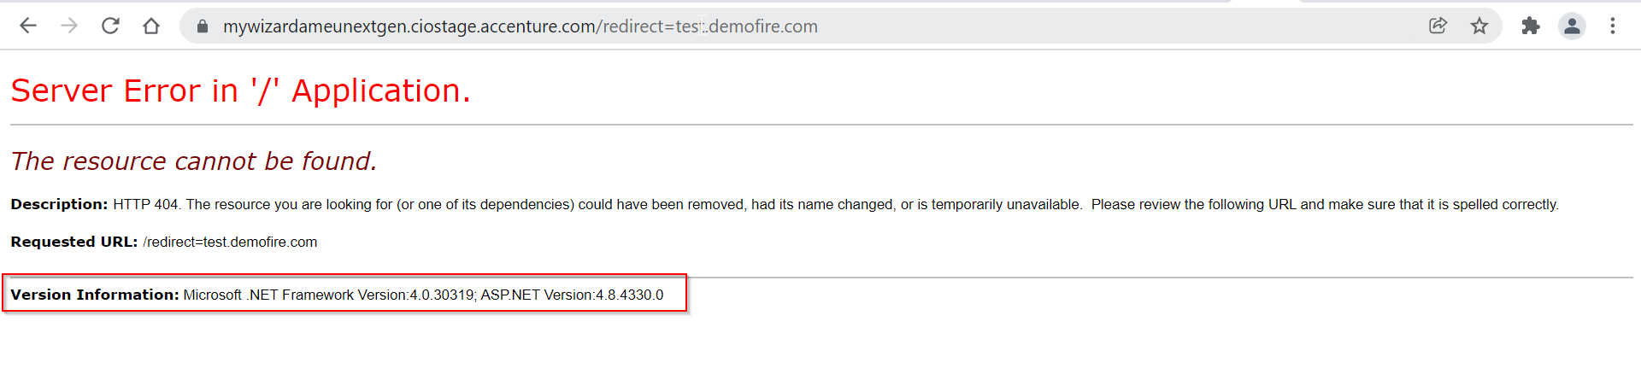

Generic error message has not been disclosing for the above scenario getting server error and version details. It’s a finding

## [​Testing for Cacheable SSL Pages](https://ts.accenture.com/Sites/CIOSecurityAudit/CIO%20Security%20Assurance%20and%20Compliance/Tools%20Initiative/ToolsWiki/Manual%20Test%20Procedures/Testing%20for%20Cacheable%20SSL%20Pages.aspx):

Log out of the application. Close and re-open the browser.

FireFox: Type **a*bout:cache*** in the address bar.

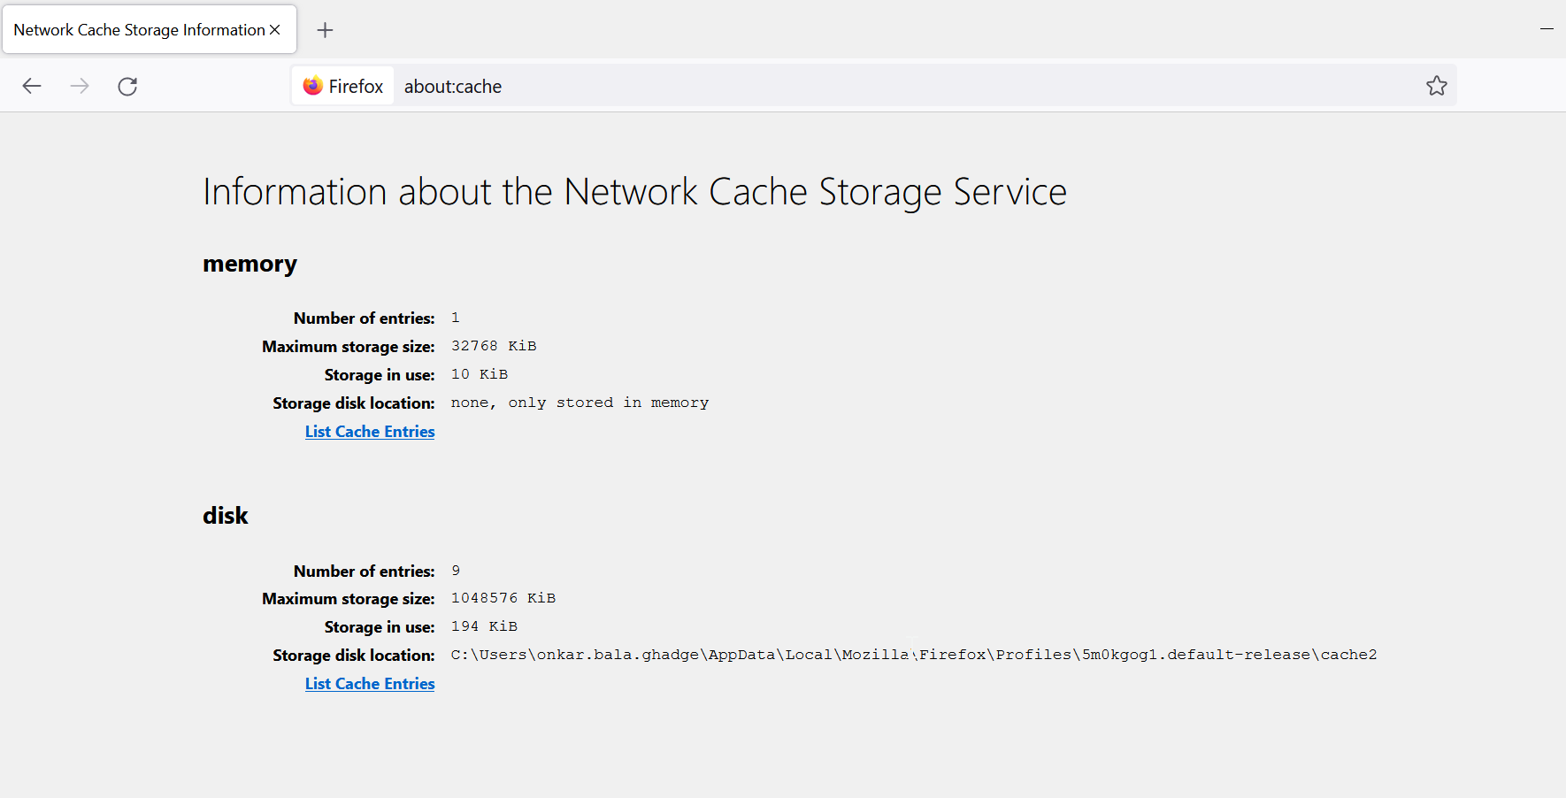

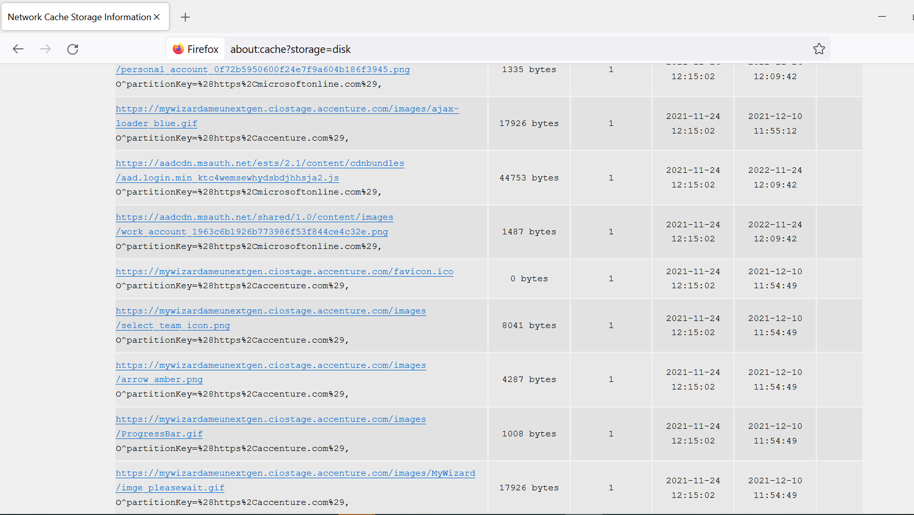

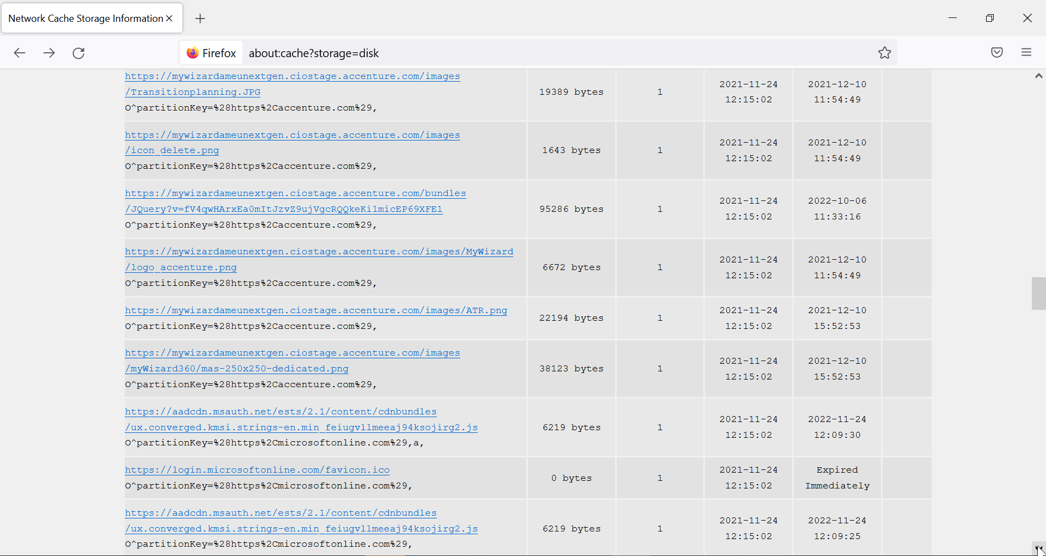

No confidential info disclosed as cache information.

## Unpatched Java script Libraries:

Access the application using these browsers and open Wappalyzer.

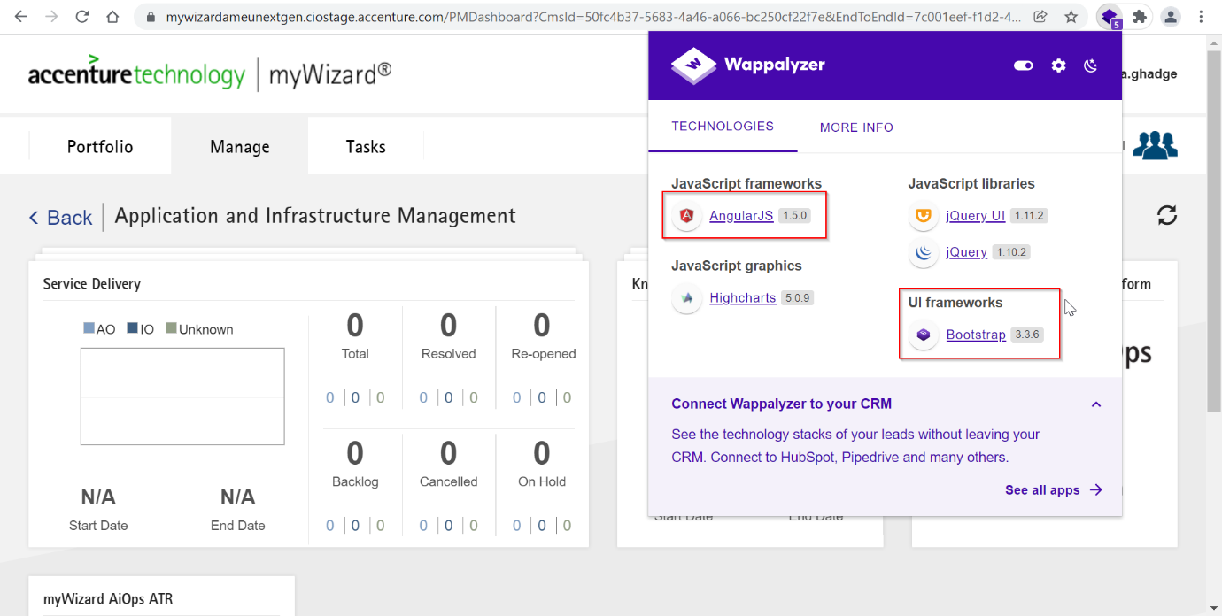

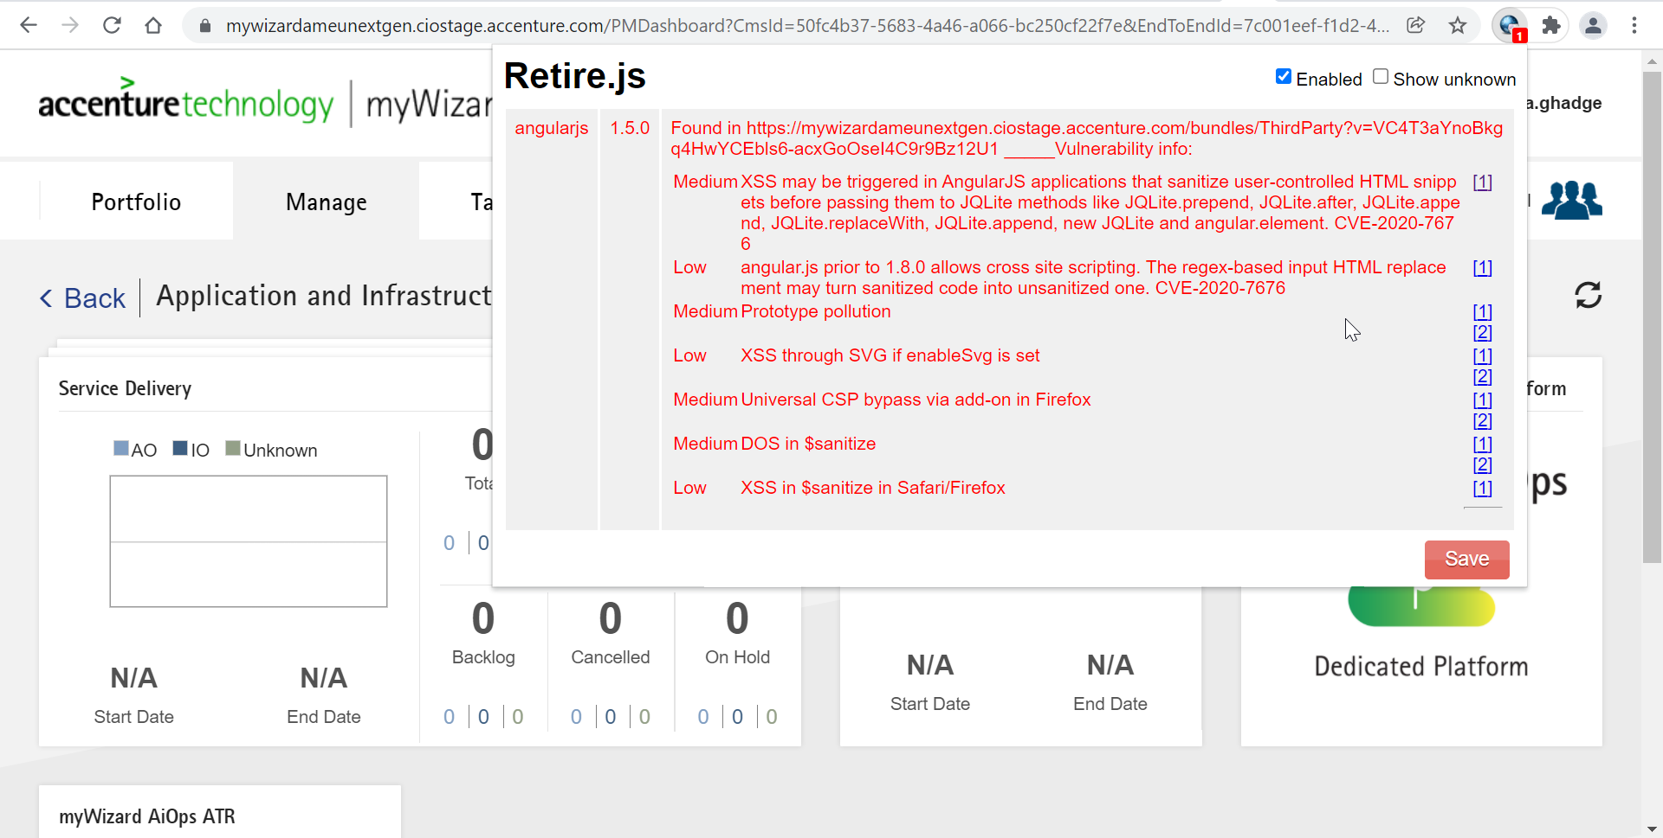

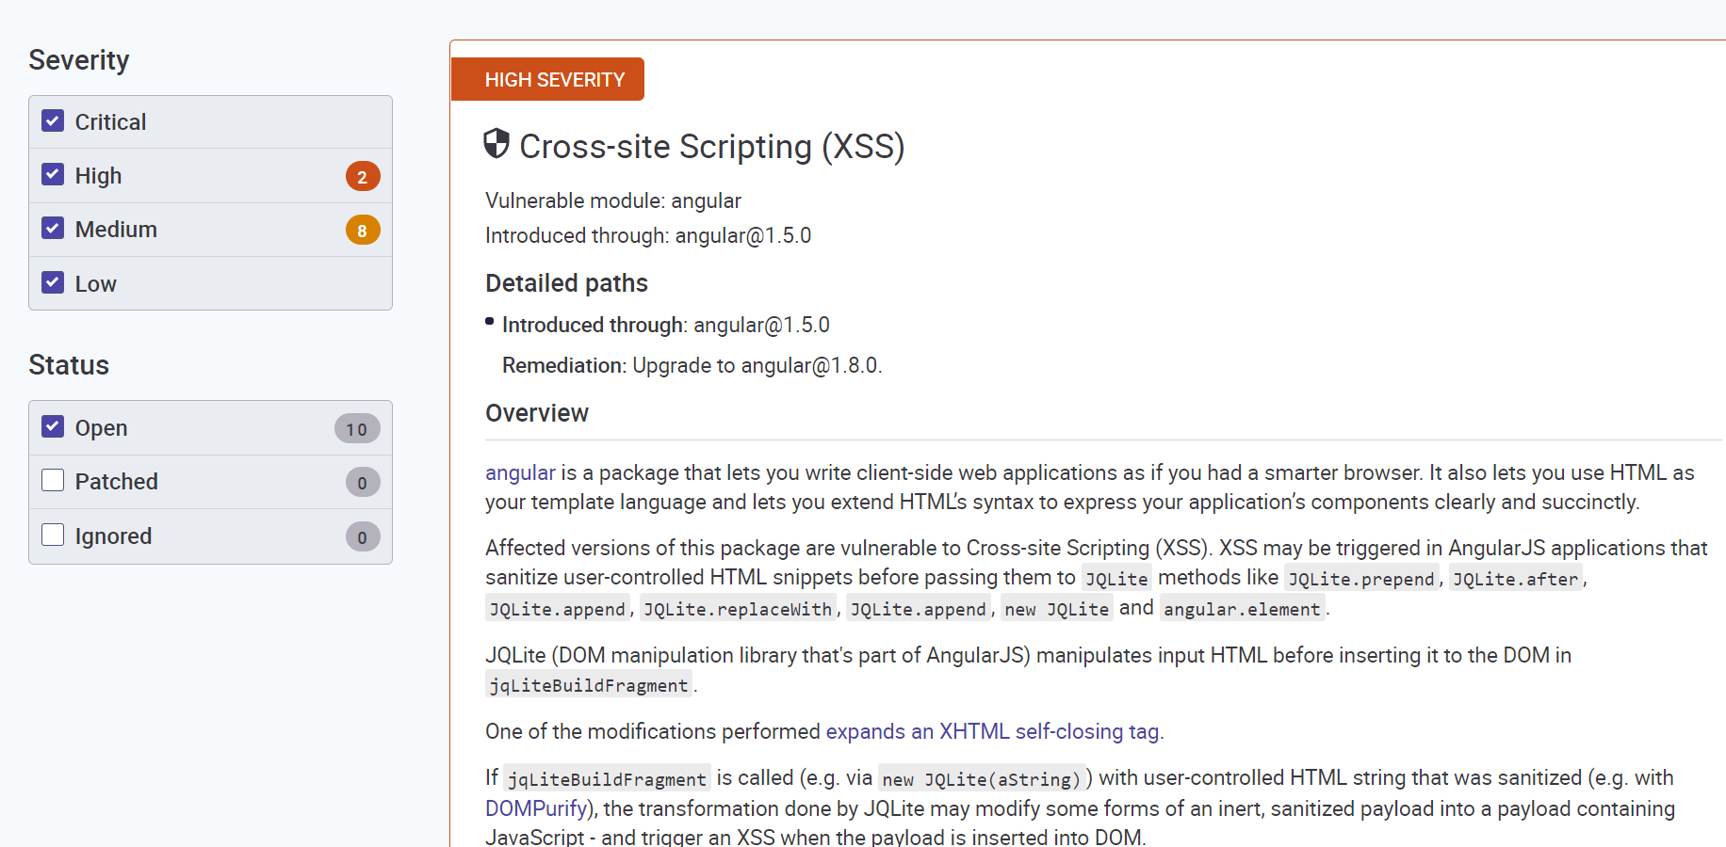

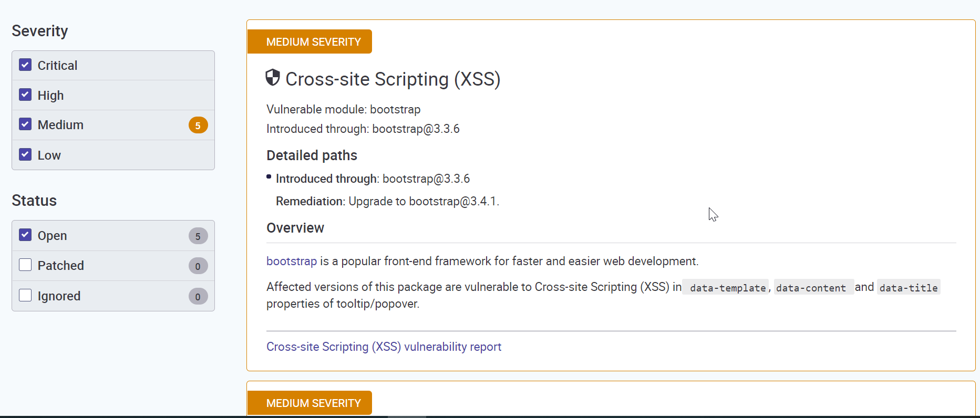

Bootstrap 3.3.6 is vulnerable to the XSS

Application uses Angular version 1.5.0 is vulnerable to the XSS

# Security Misconfigurations:

## Robots.txt:

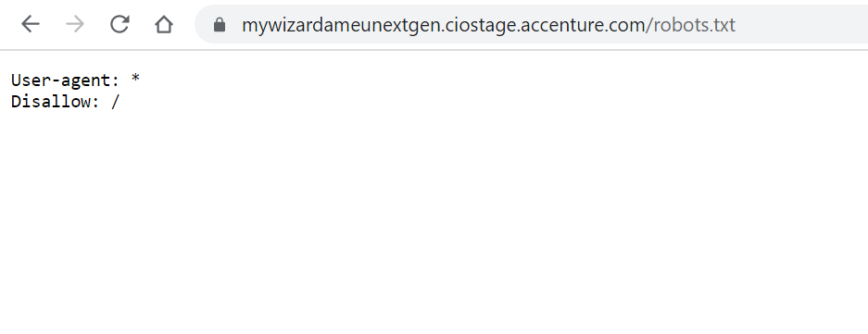

Robots.txt is implemented in the application

## Exposure of applications. git directory

Trying to access URL using. git directory

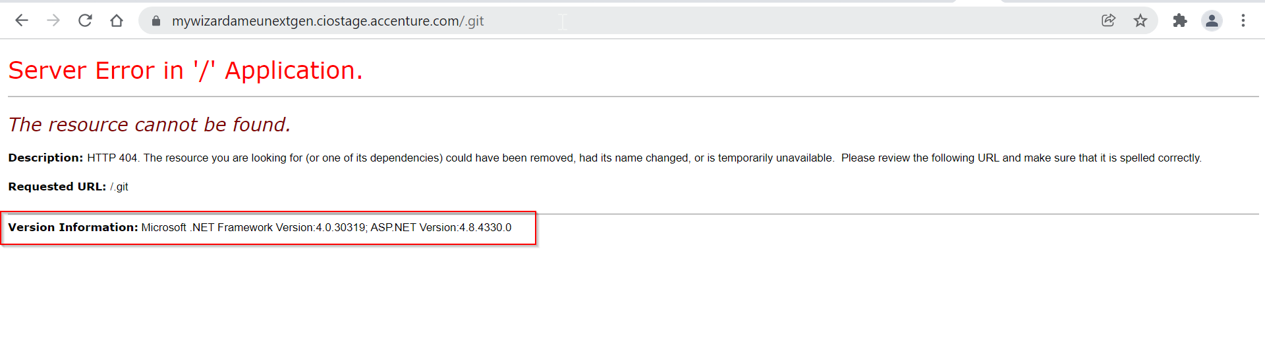

Generic error message has not been disclosing for the above scenario getting server error and version details. It’s a finding

Server Error message showing version details was disclosed.

## Testing for Web Application Fingerprint:

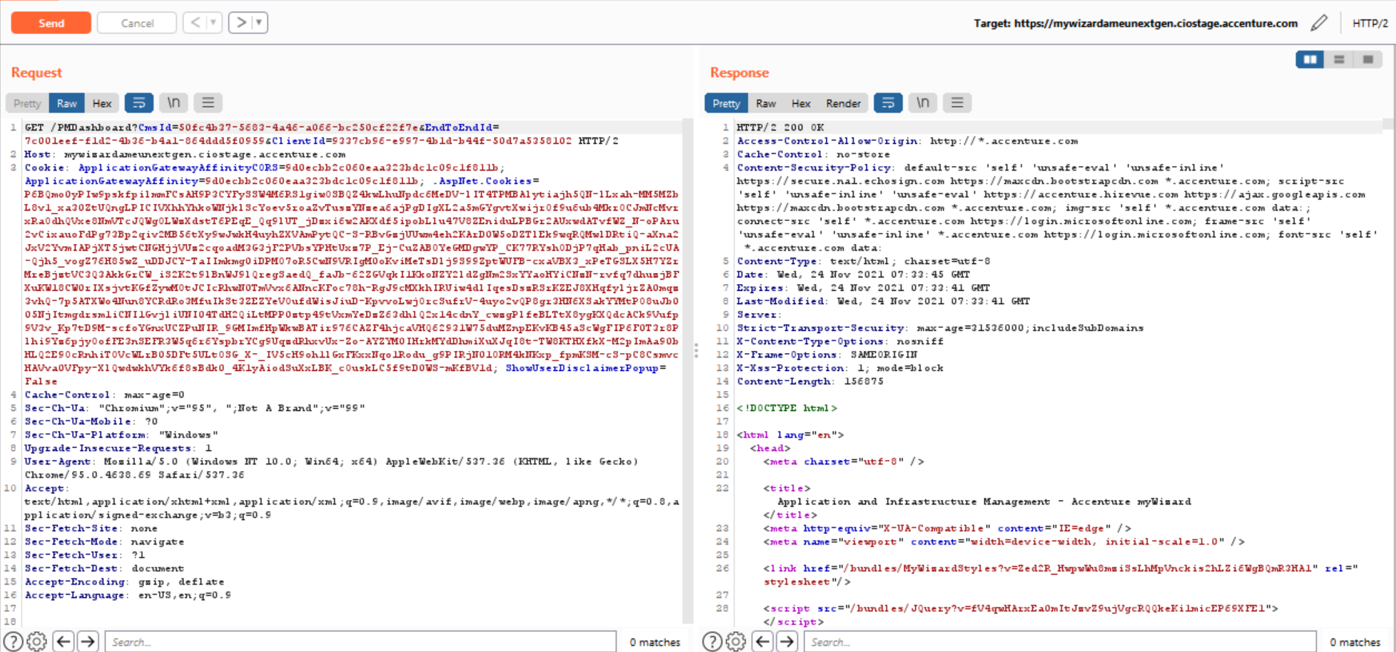

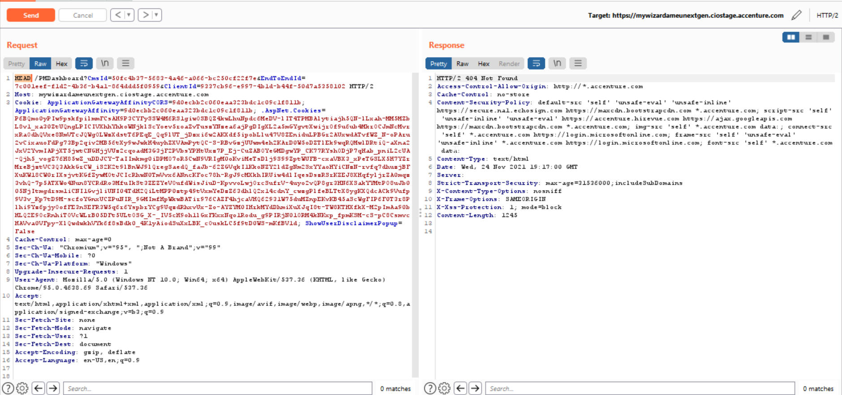

As the GET request converted to HEAD request, 404 error with the message “Not Found”. No sensitive Information discloses.

## Application Discovery:

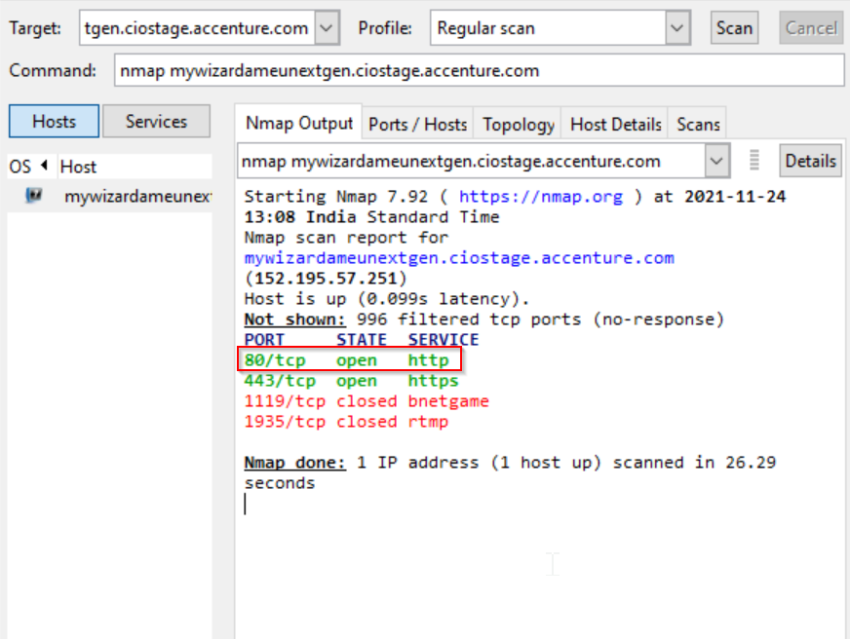

Port 80 is open in the application.

## Testing for Tilde Attack

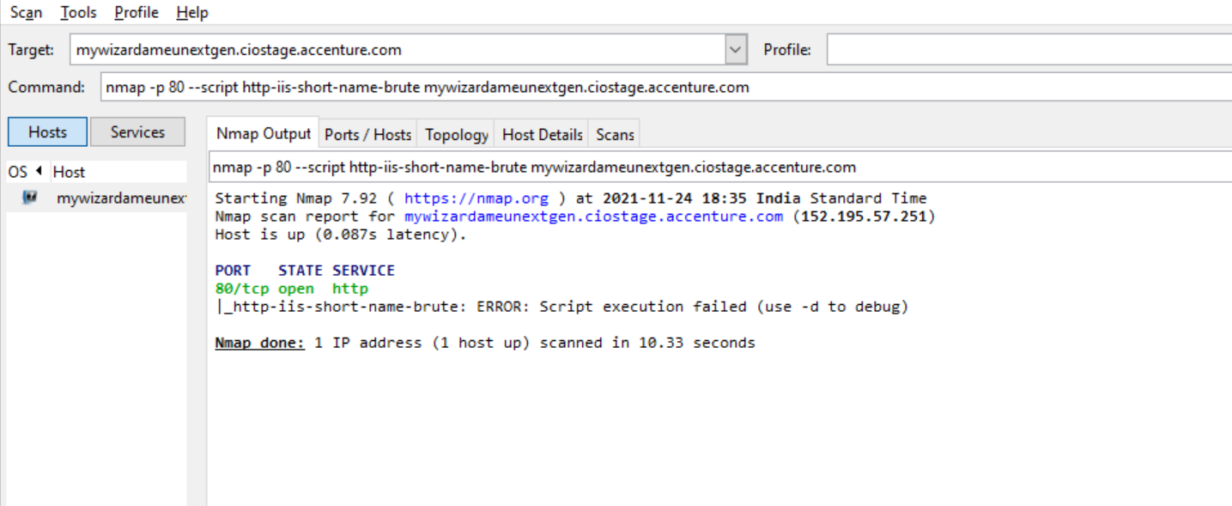

Port 80 is open in the application.

## Testing for HTTP Methods and XST:

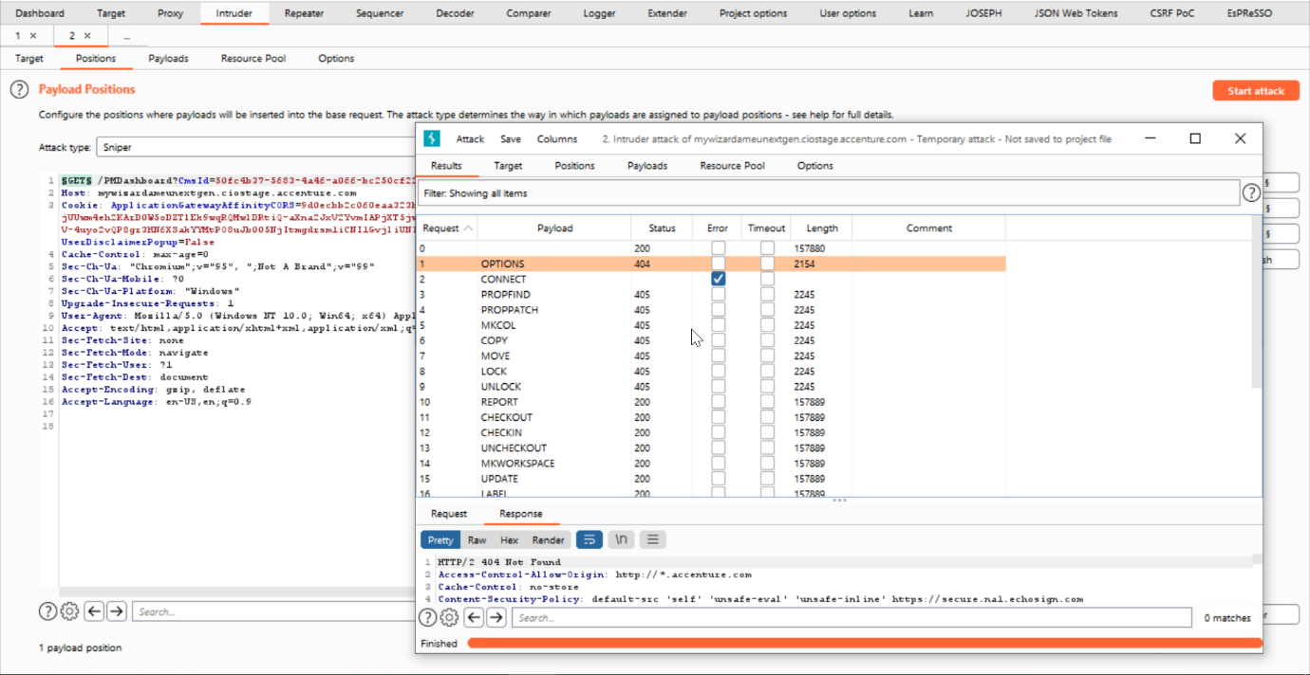

Only GET method is allowed. Error message has been displayed for the other methods.

## Testing for security headers:

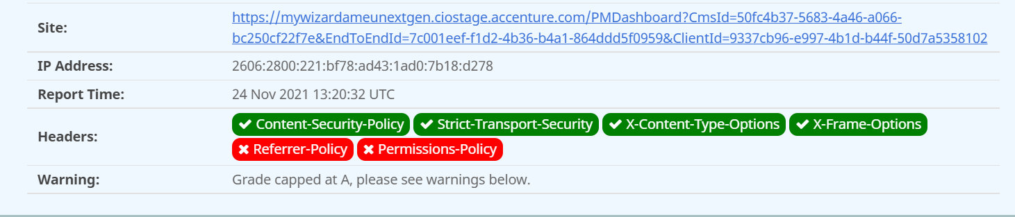f

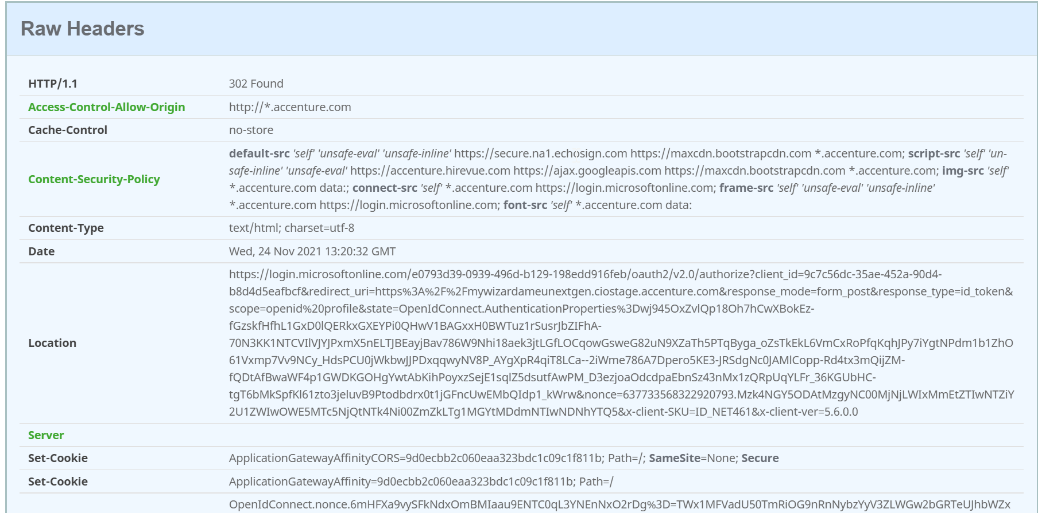

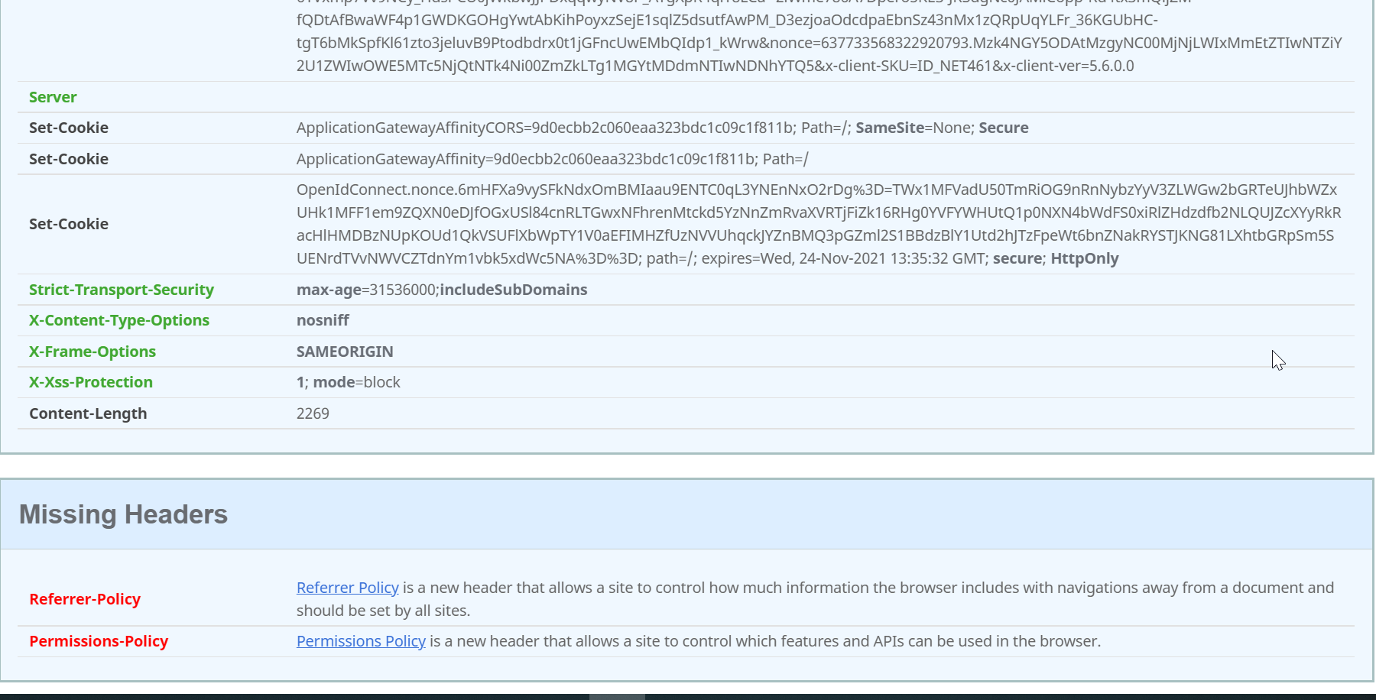

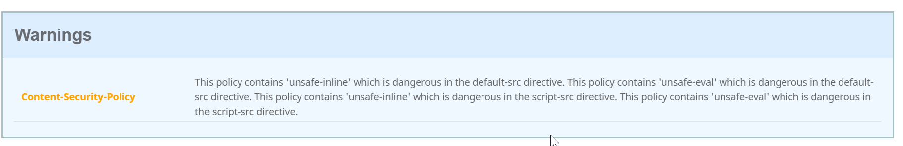

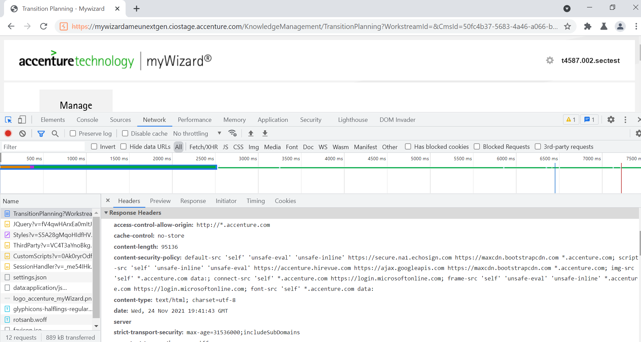

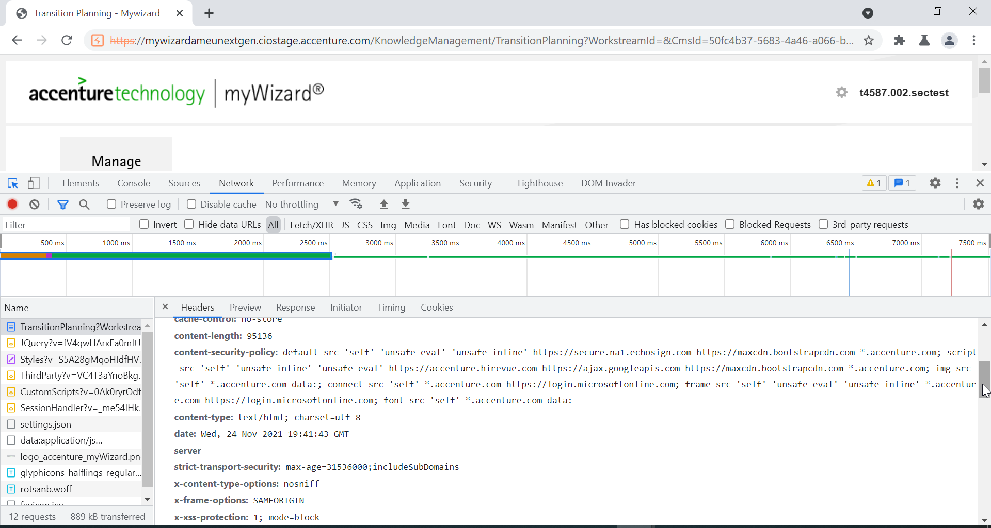

## Test for Subresource Integrity (SRI) Support:

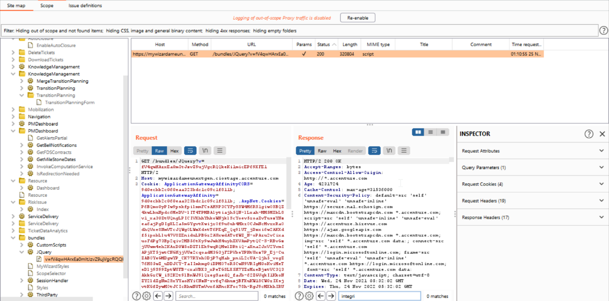

Scripts is observed, but we did not observe the “integrity=” attribute, hence not a finding

## SSL/TLS testing:

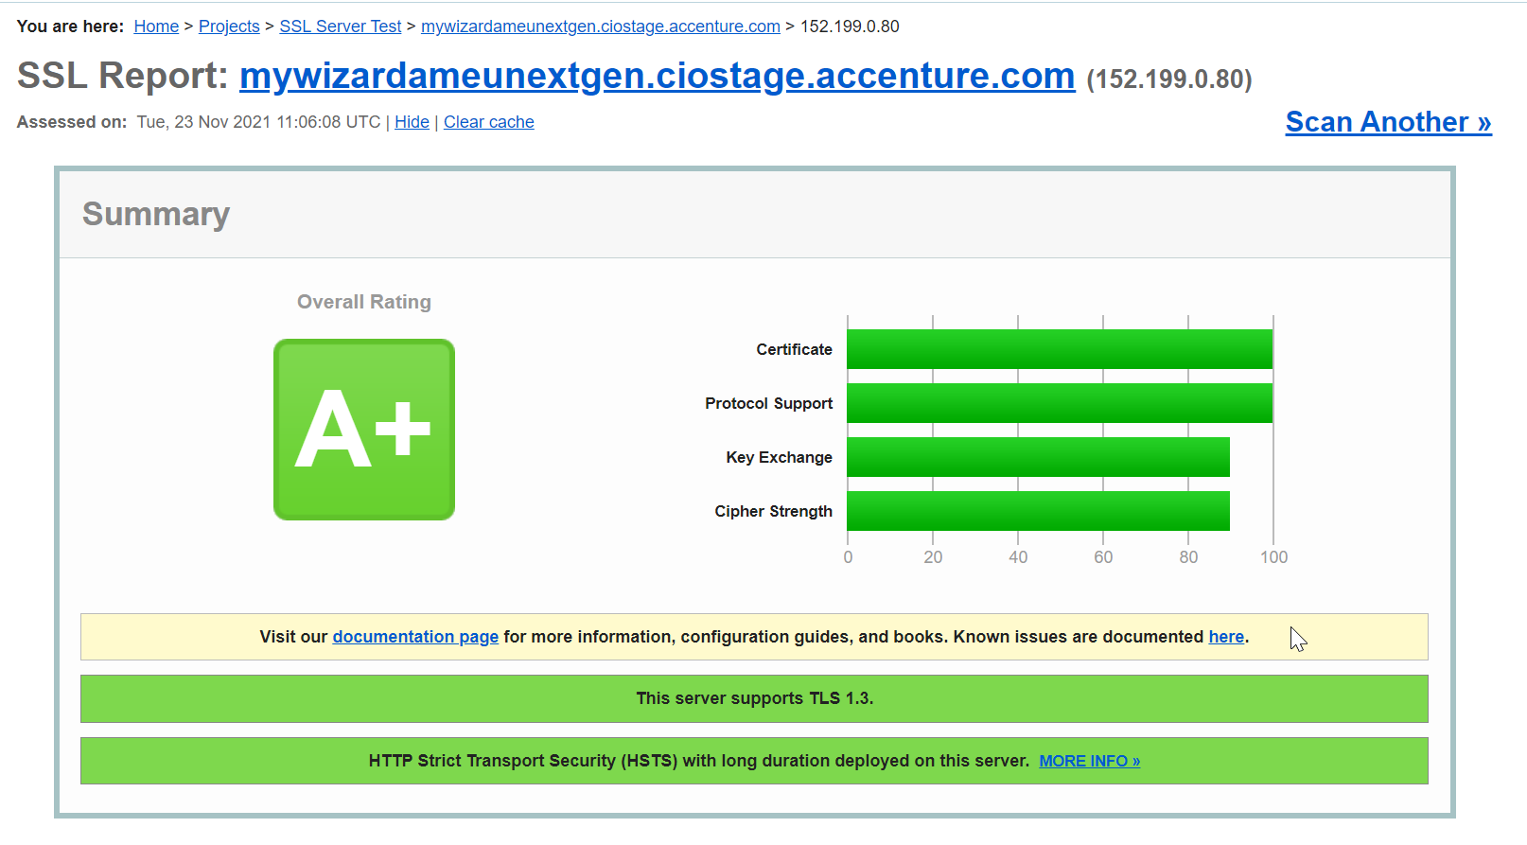

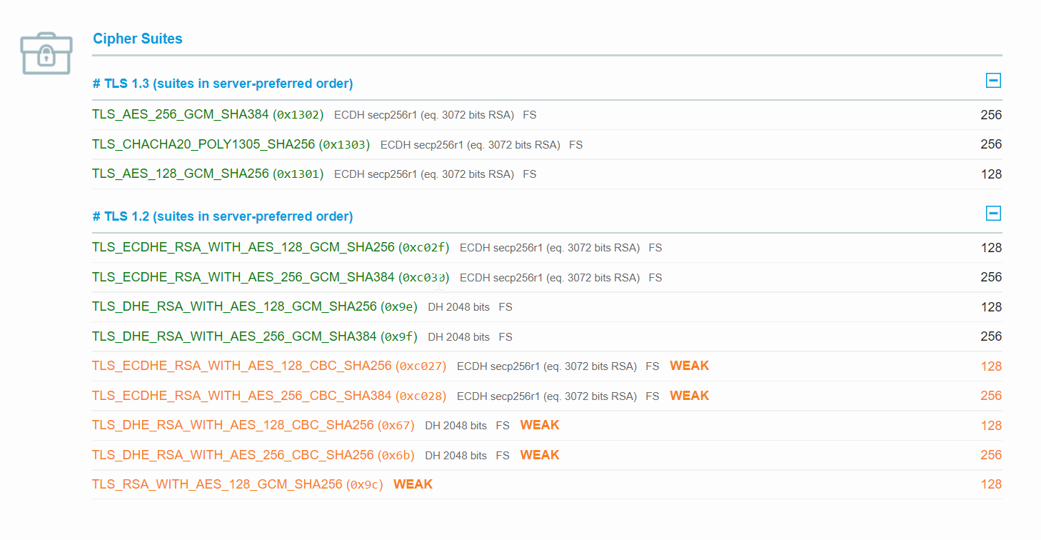

Weak ciphers are identified.

## Clickjacking test:

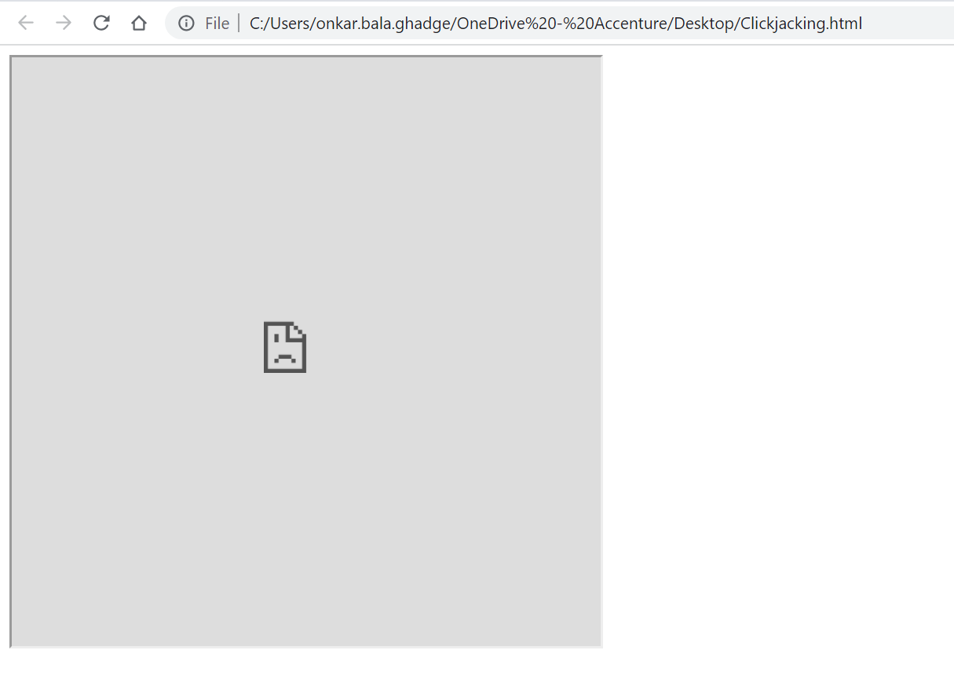

Application is not vulnerable can’t load within an iframe. Clickjacking is not possible.

## HTTP Request Smuggling:

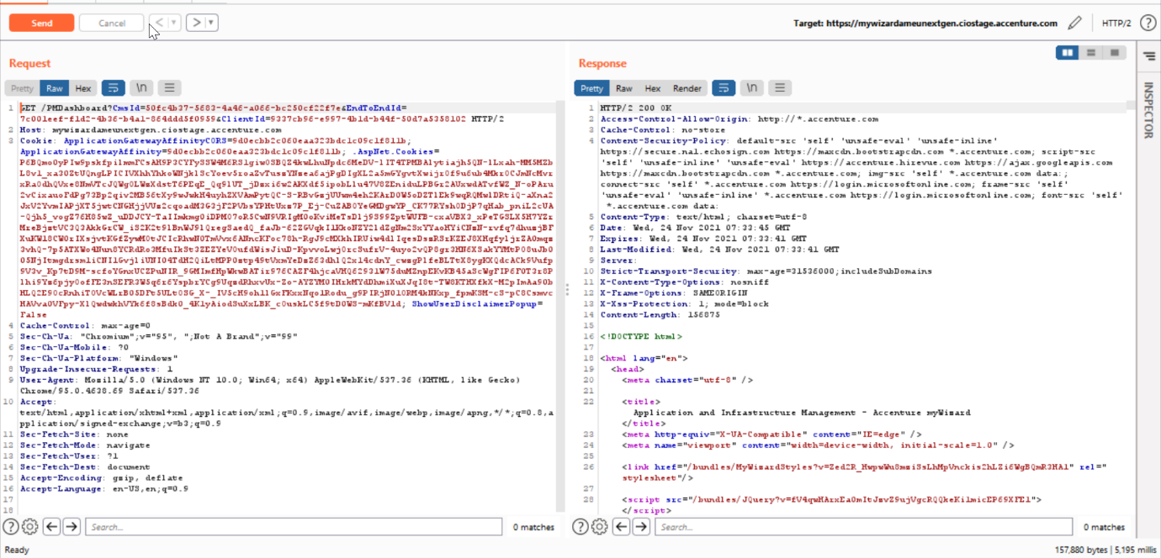

Original GET request.

Adding GET /robots.txt HTTP/1.1 at the end of the request

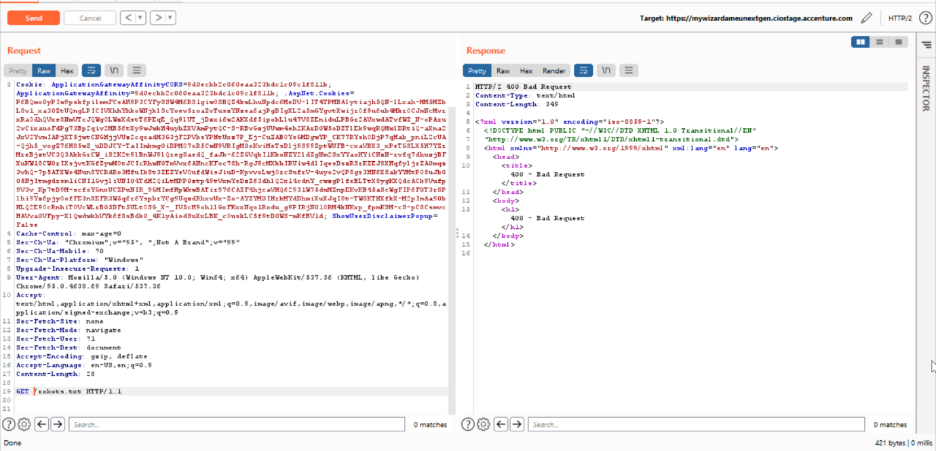

Request Smuggling is not possible.

## Unencrypted View state:

Application is not using the view state.

## CORS:

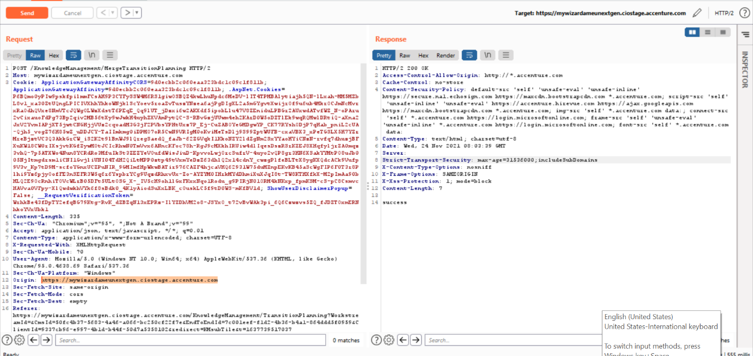

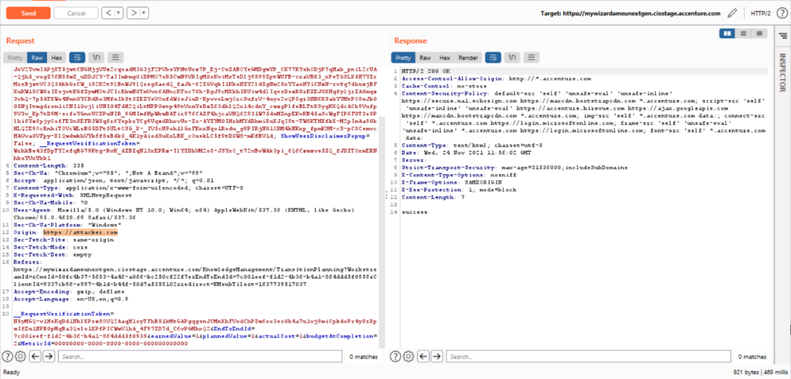

The Cross-Origin Resource Sharing (CORS) policy configured properly in the application.

# Session management:

## Testing for Logout and Browser Cache Management:

The browser ask for a new login, when closed and opened again.

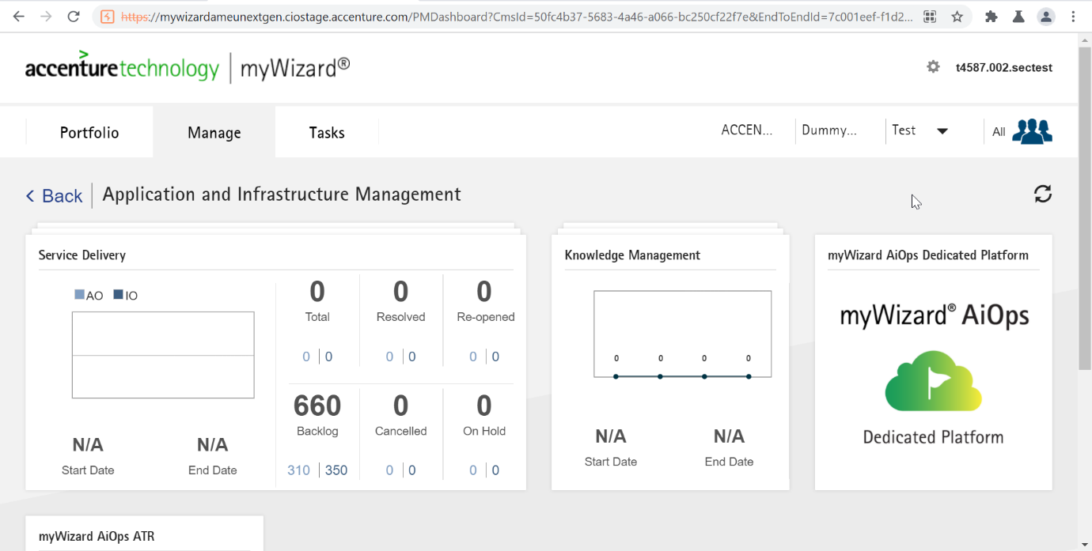

Logout from the application and Click on back arrow

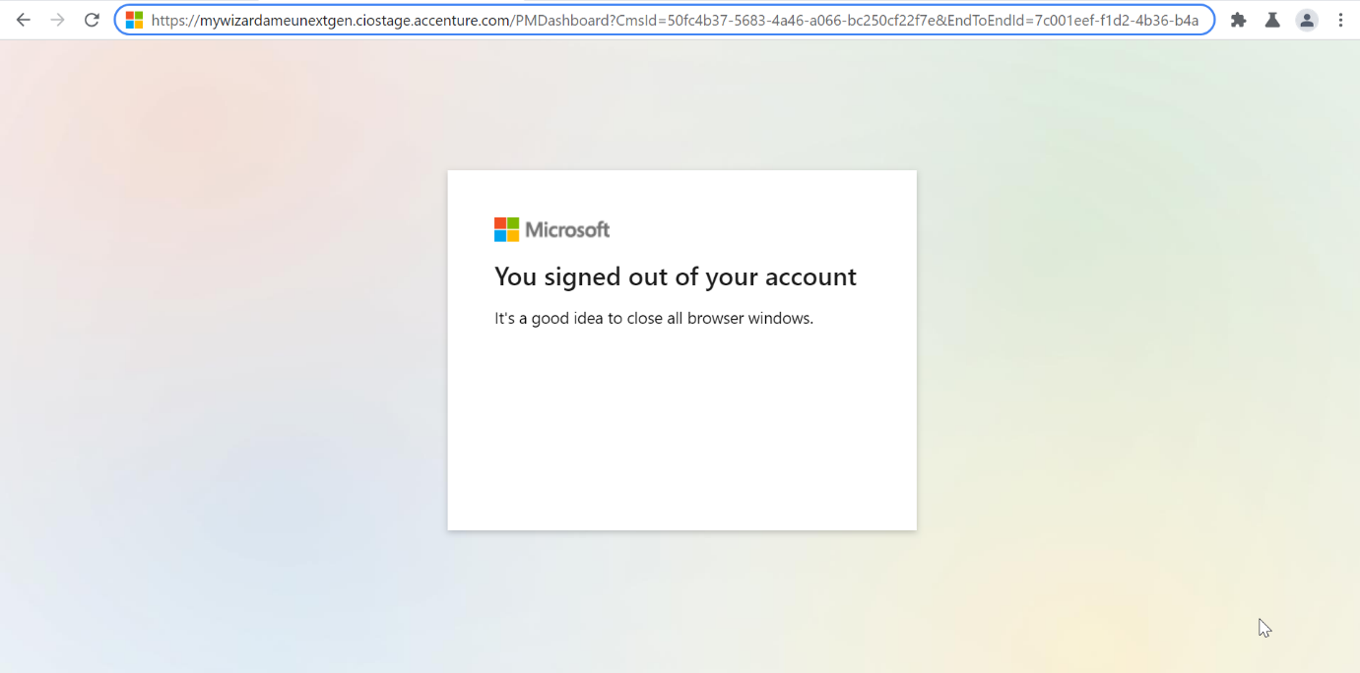

Logout functionality has implemented correctly. No findings identified.

## Testing for Session Management Schema:

Exporting all cookies after login and then logout the application.

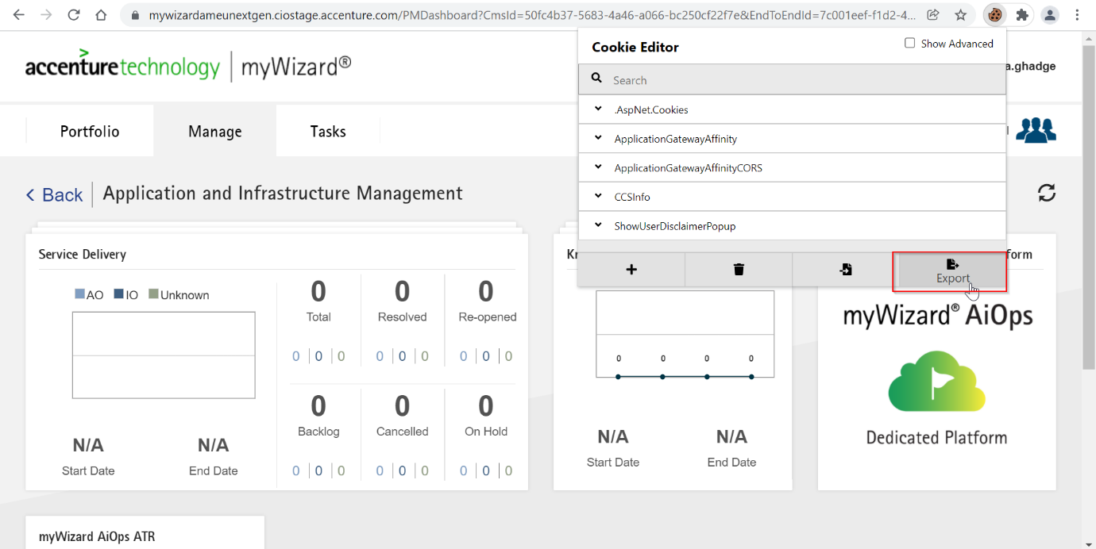

Log out and clear all cookies on login page and try to import all exported cookies.

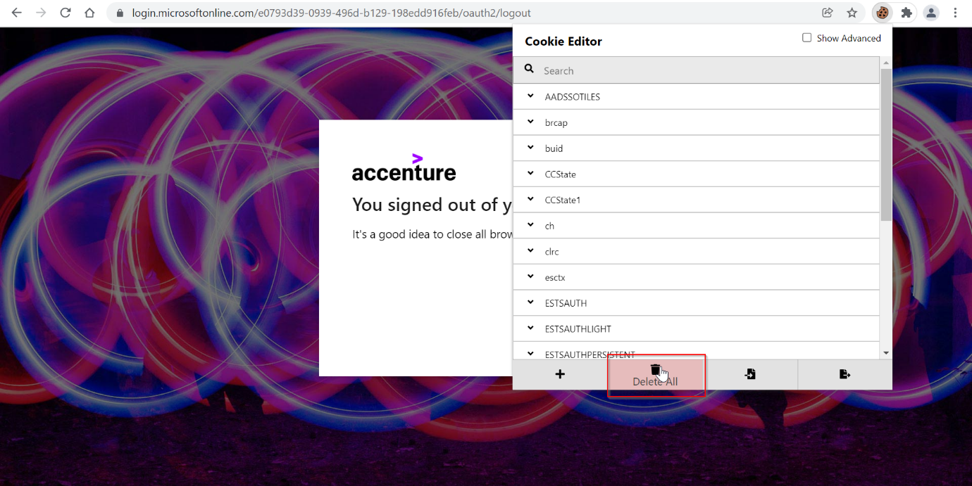

Log out and clear all cookies on login page and try to import all exported cookies.

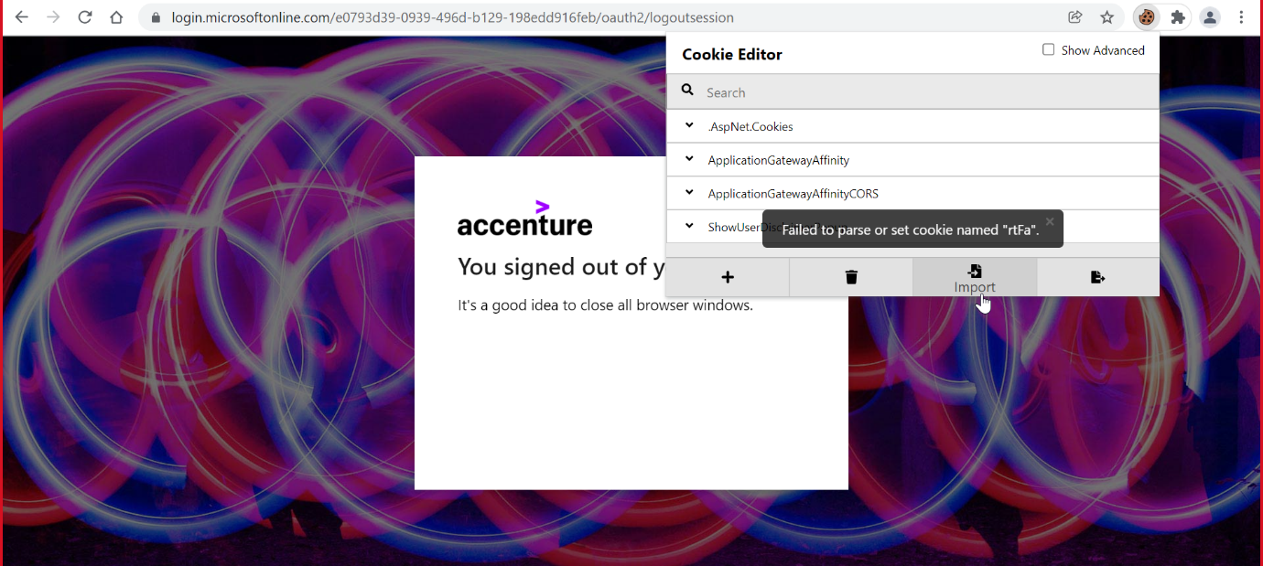

Permissions denied for setting the cookie.

## Testing for Cookie attributes:

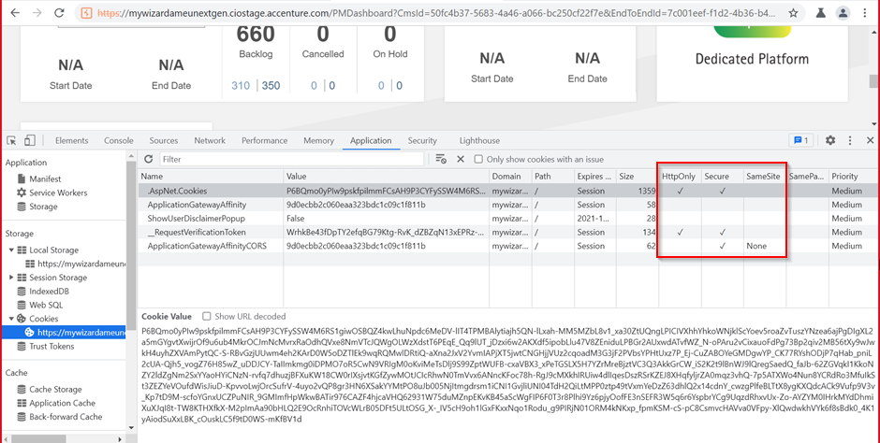

Cookie attribute http only, Secure, Samesite are not set properly

## Testing for session fixation:

Login and copy sessionid and logout

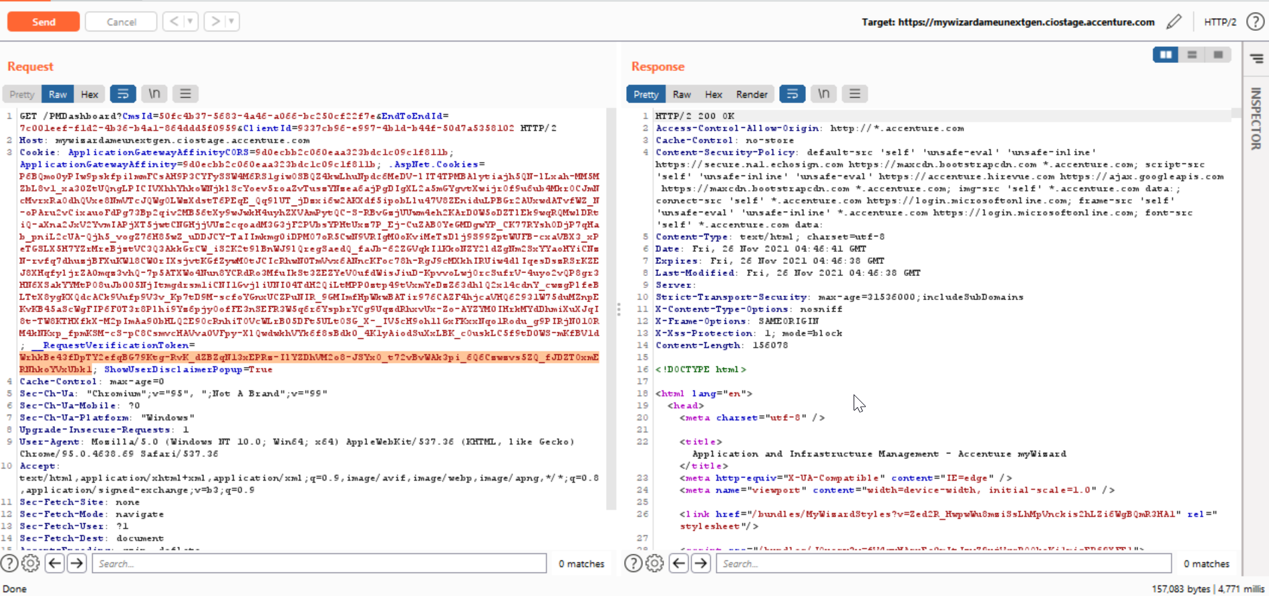

Login again and copy session id and check whether the session id is changing or not:

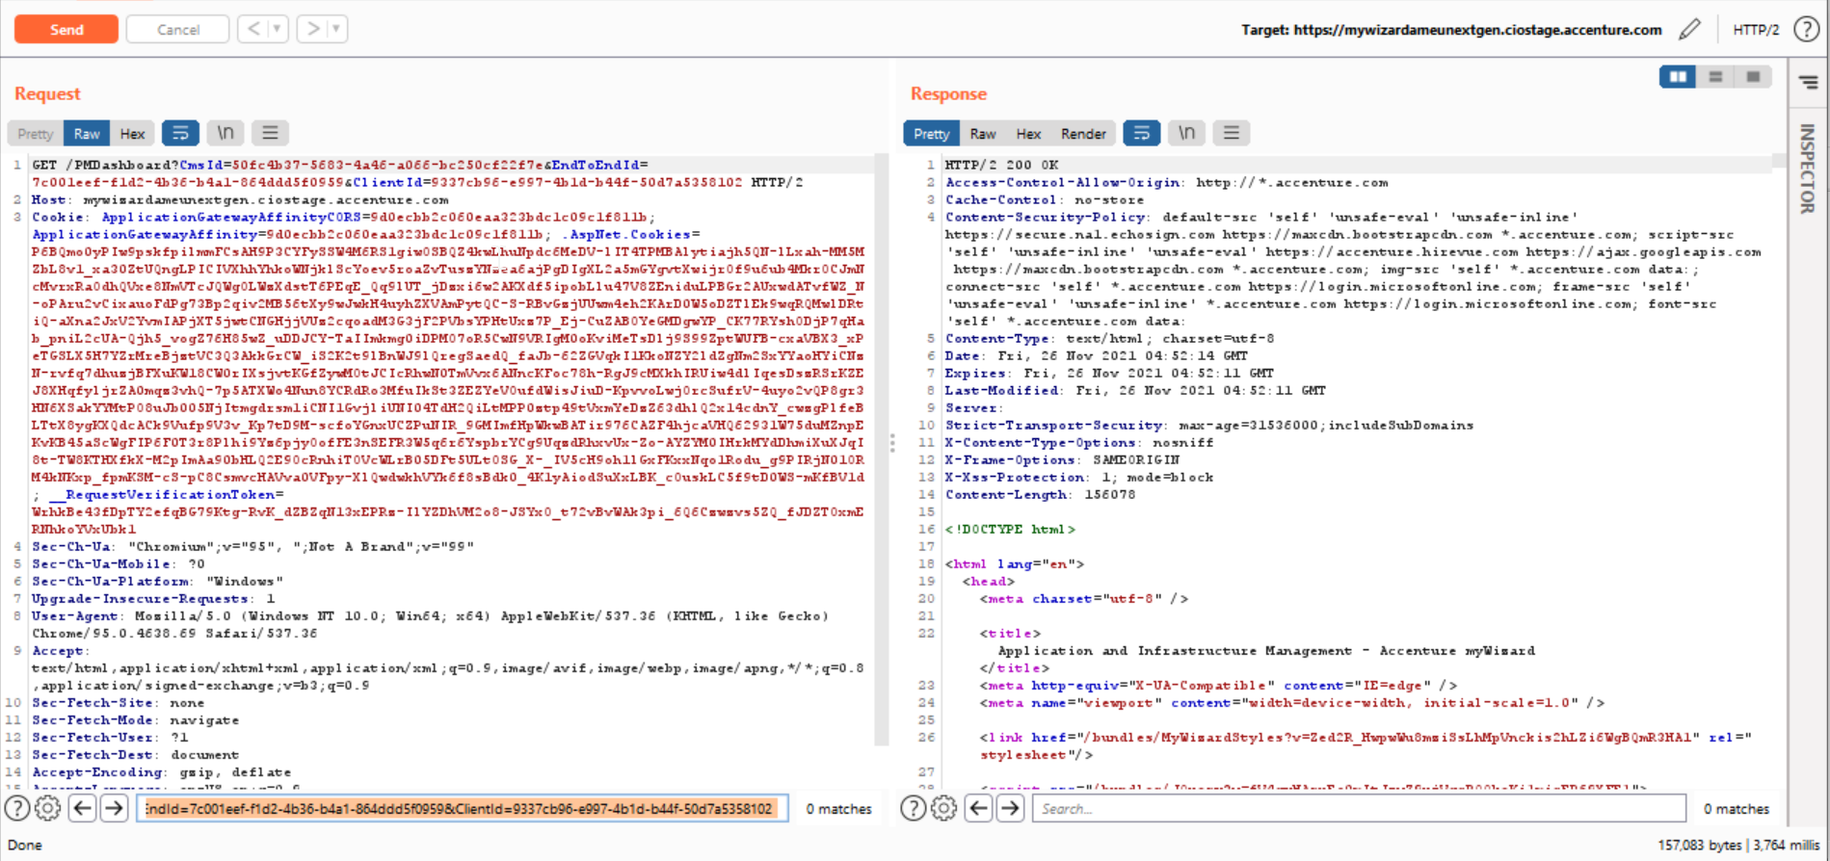

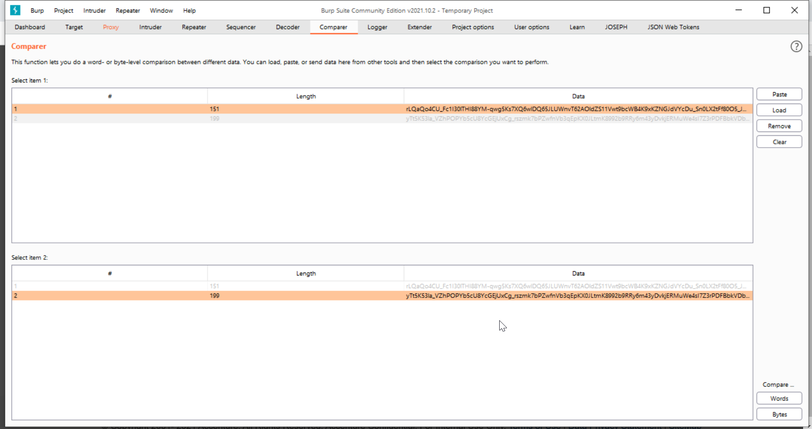

The session ids are unique for every login; hence it is not a finding.

## ​Testing for Exposed Session Variables:

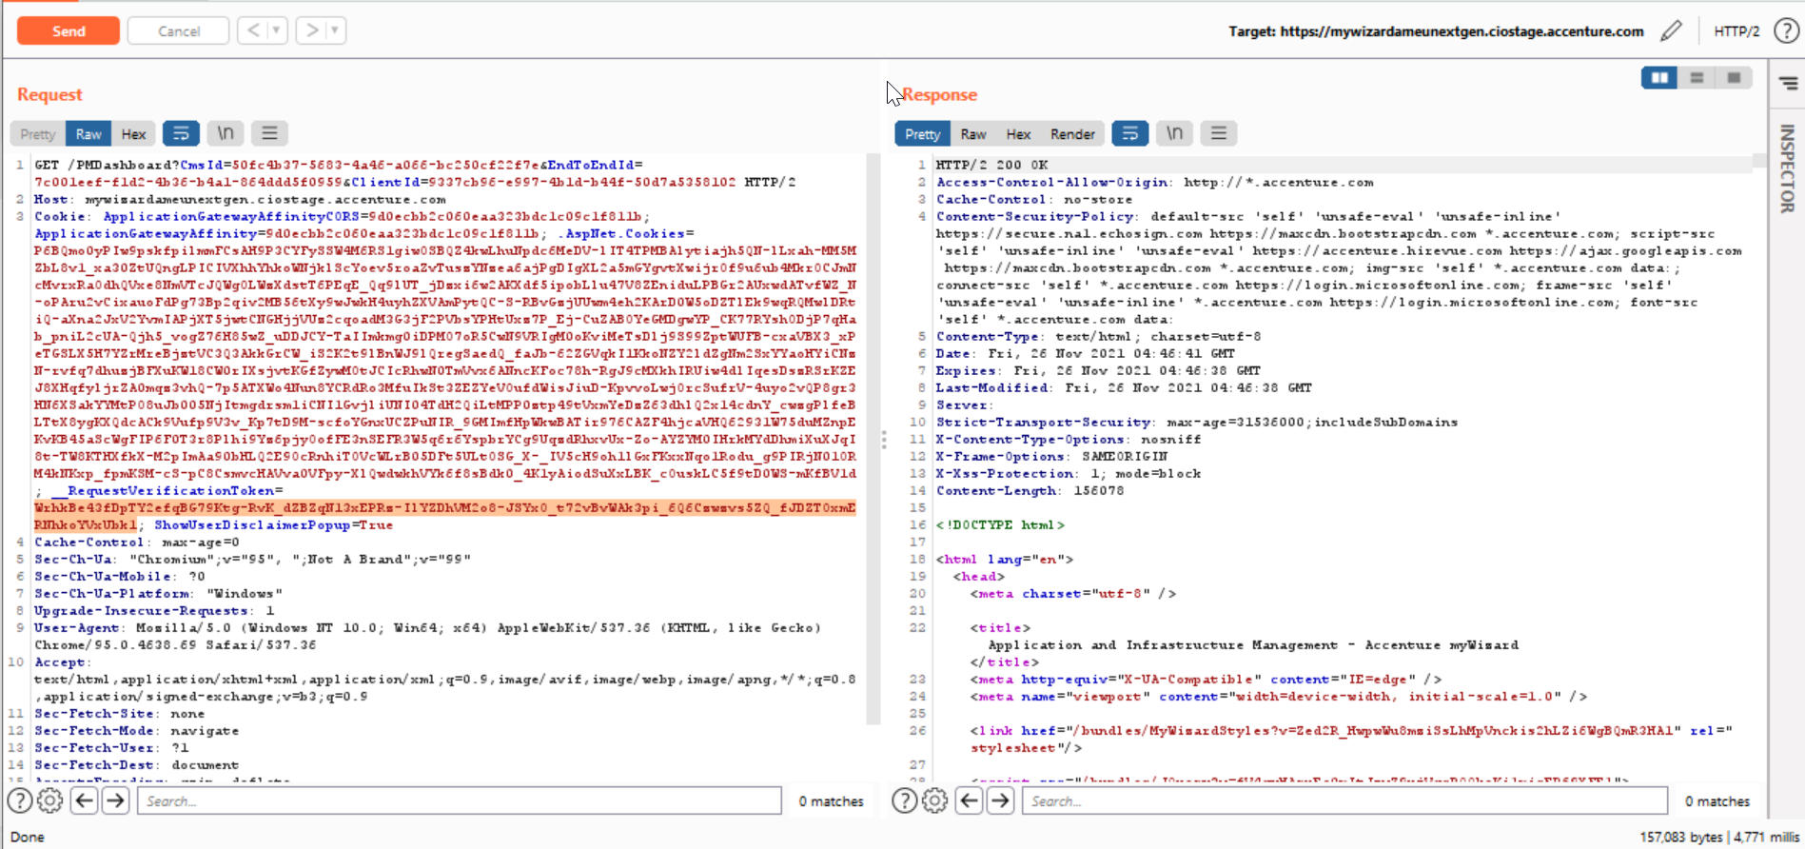

​ Session id variables are passing in cookie only and not passing in url parameters. Hence, it is not a finding.

## Test for CSRF:

Created a CSRF POC after intercepting requests (action performed), using the generated POC the request was sent from a new tab in the browser.

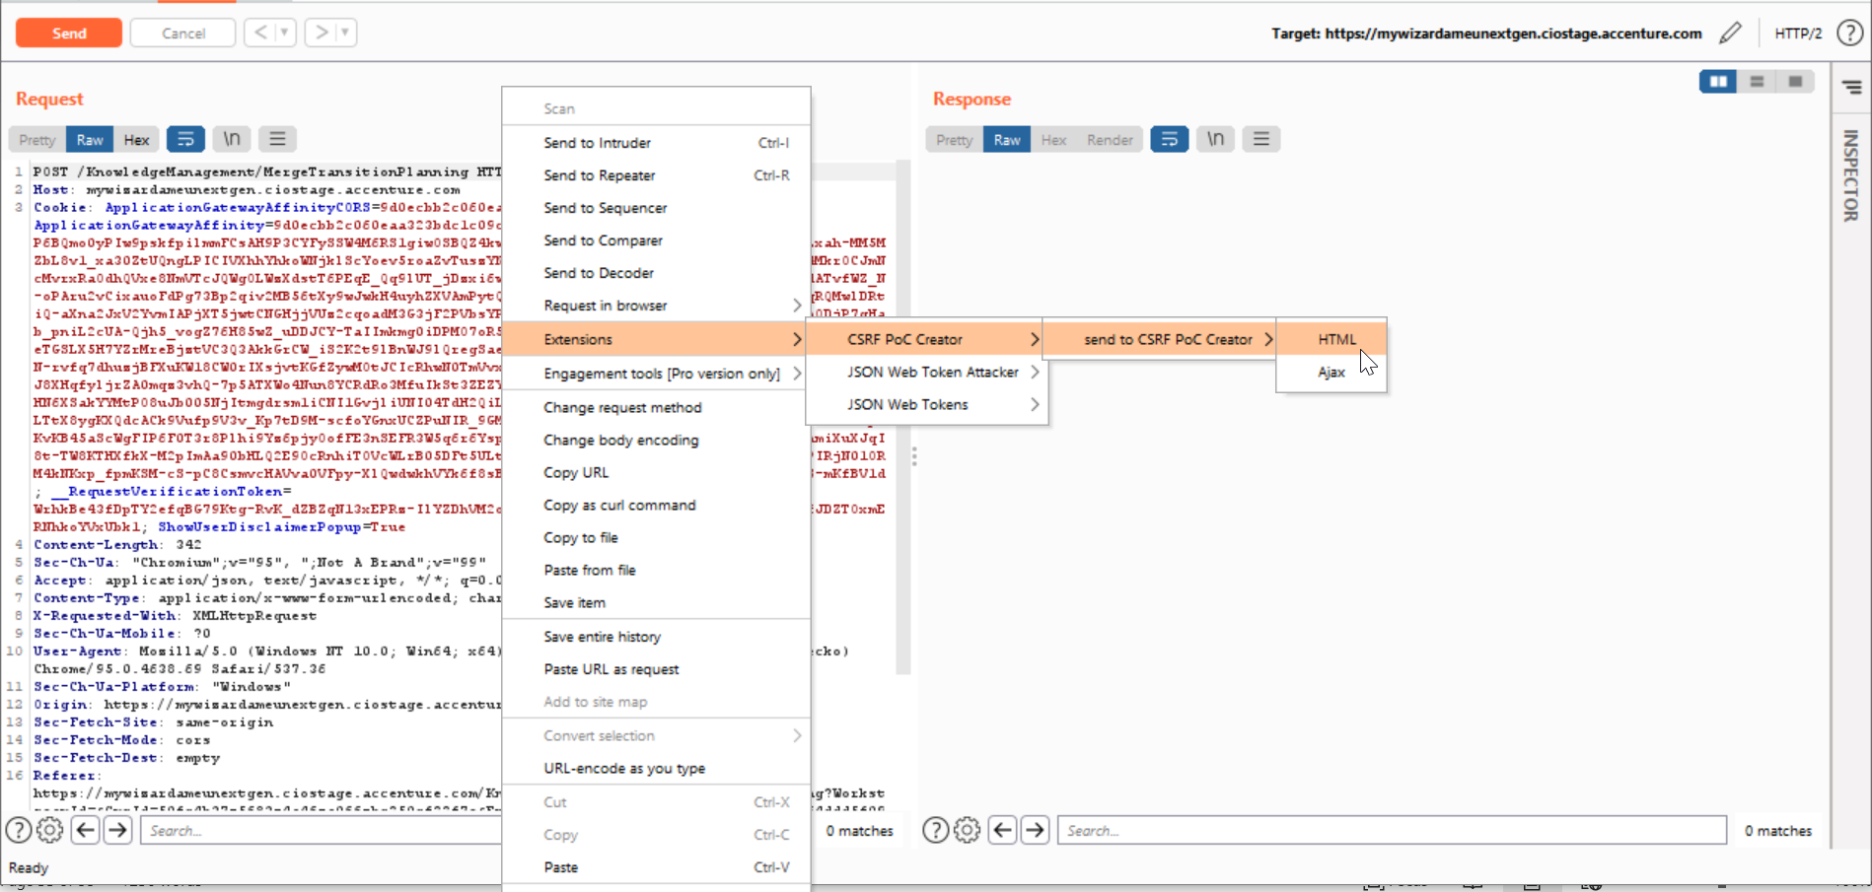

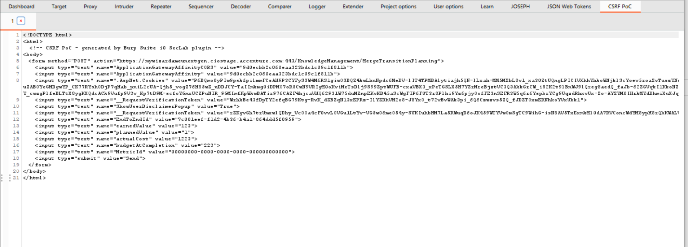

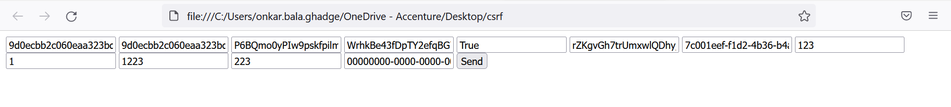

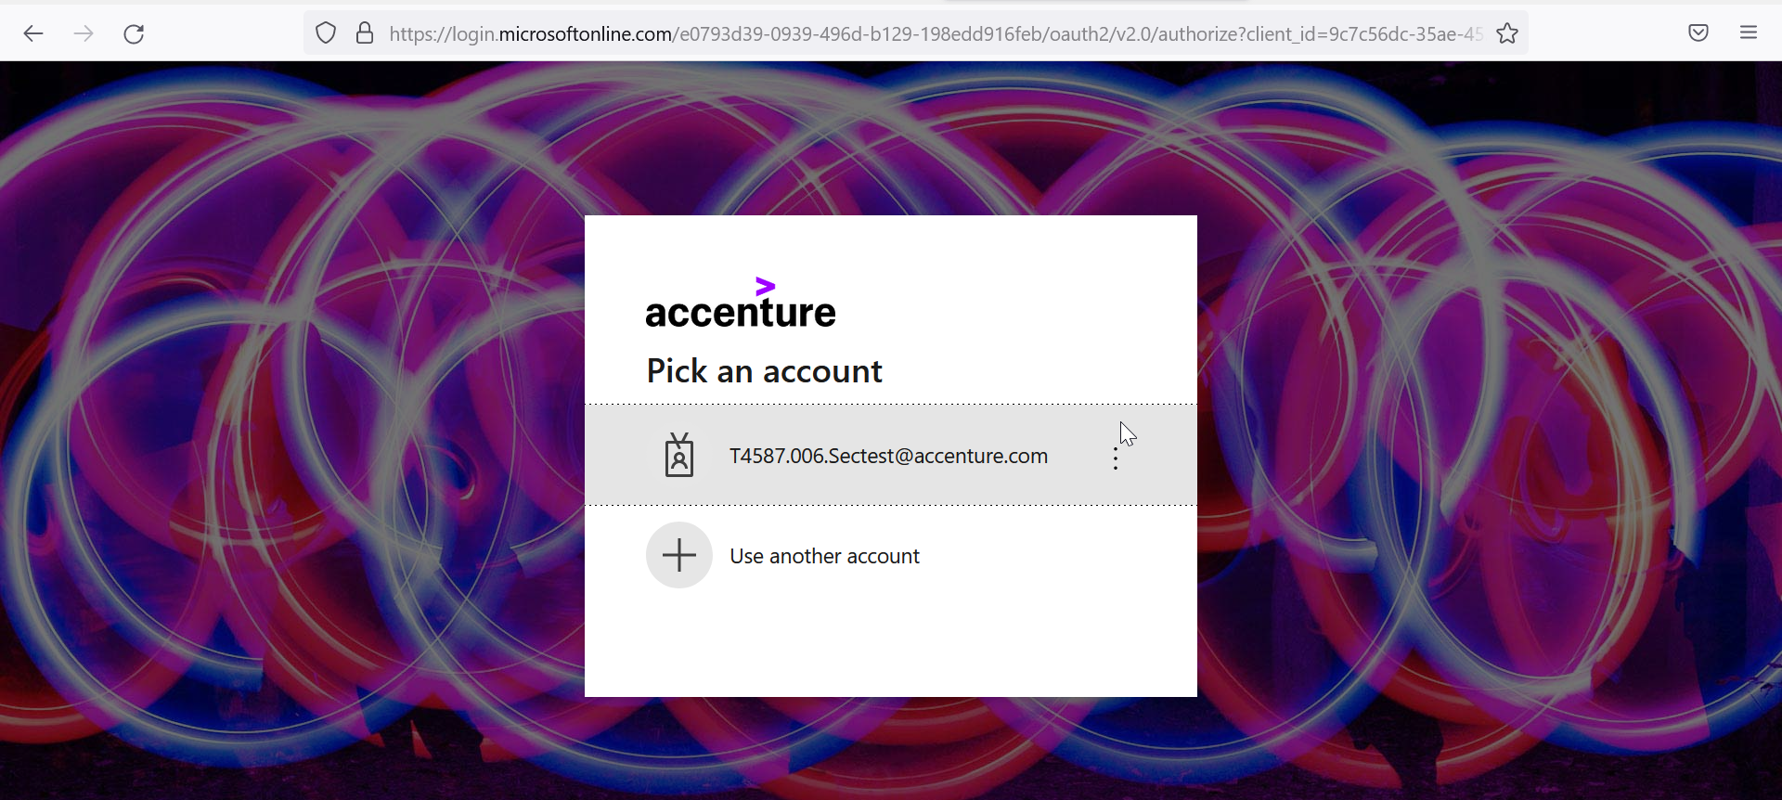

# Authentication Testing:

## Testing for Local, Administrative or Alternate Logins:

## Multi-factor Authentication Testing:

## Testing of Unauthenticated Directories - using Burp Plug-in

NA. No unauthenticated directories are found.

## Testing for Password Complexity Compliance

Not Applicable. SSO is configured

## Testing for password's autocomplete attribute:

Not Applicable. SSO is configured.

## Password Masking

Not Applicable. SSO is configured.

## Credential’s transport over an encrypted channel:

Credentials are only transported over an encrypted channel.

## Testing for Guessable User Account:

Not Applicable. SSO is configured

## Direct page request (bypass authentication)

Login to the application and Copy the results URLs.

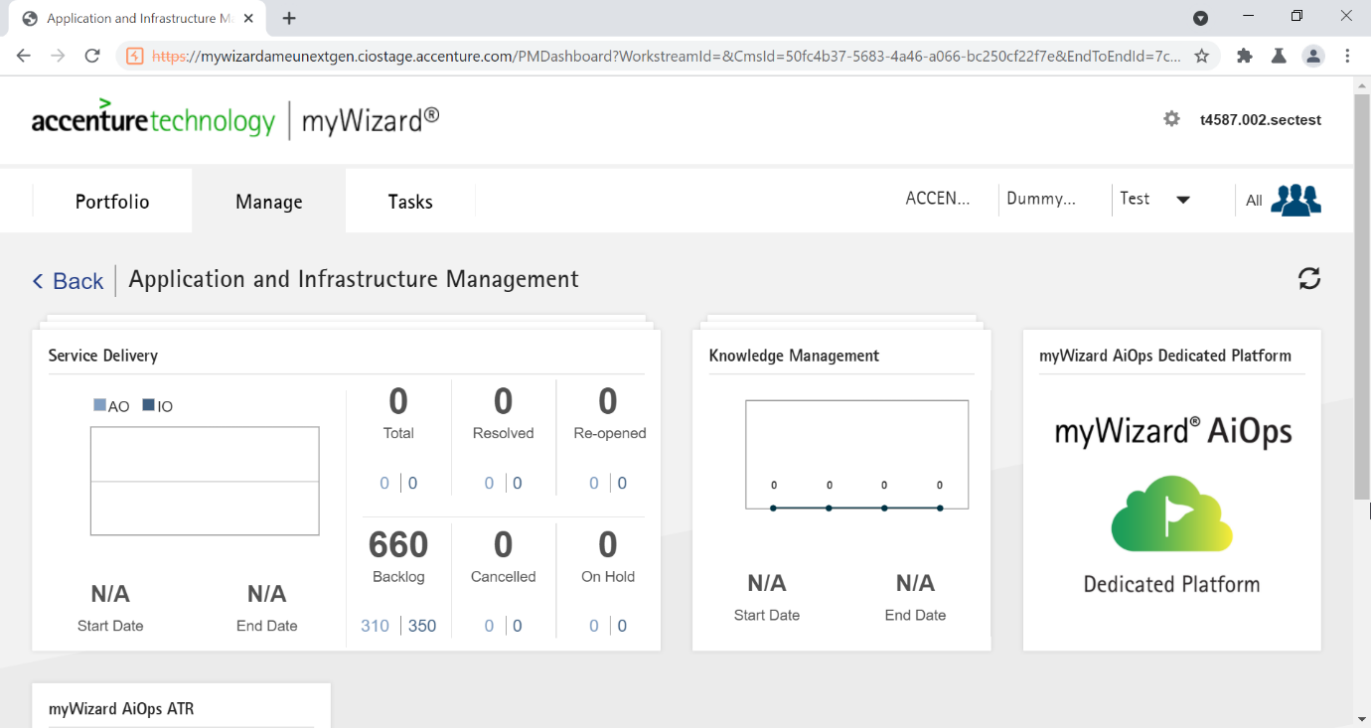

Log out and Try forceful login using copied URLs– redirected to login page

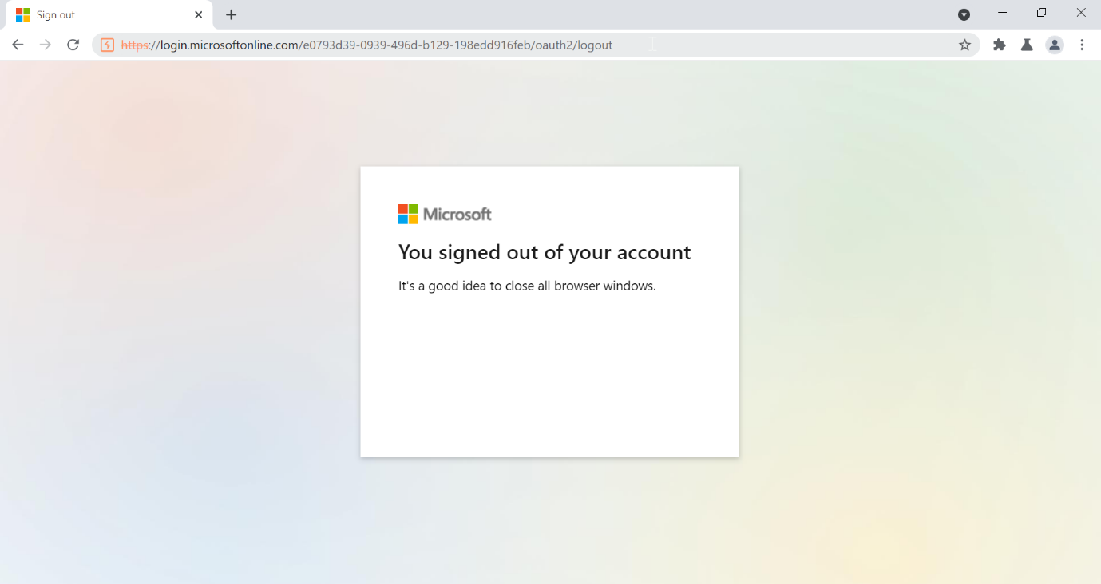

Direct page request is possible



## Testing for vulnerable remember password, reset and enumeration:

SSO is configured.

## Parameter modification:

The application does not verify a successful login based on a fixed value parameter.

## Test for publically accessible js files

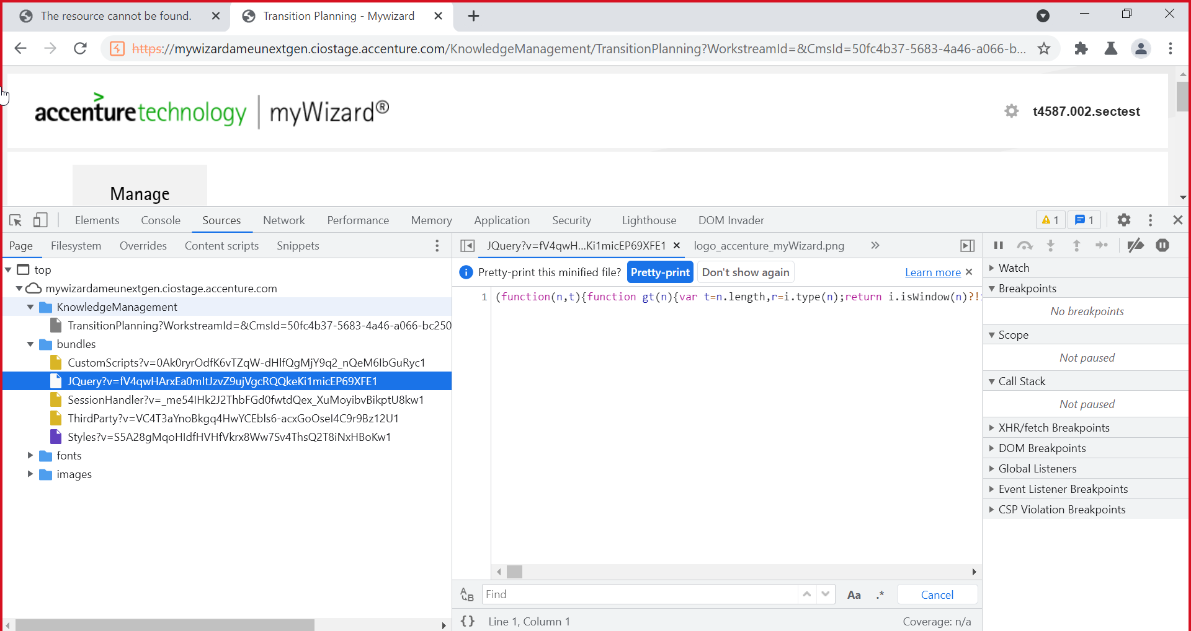

Js files are not publically accessible

## Test if API operations can be invoked without authentication:

APIs cannot be invoked without authentication.

# Authorization Testing:

## Testing for horizontal escalation:

Add the risk data in to input fields and save it. Intercept the save request in burp.

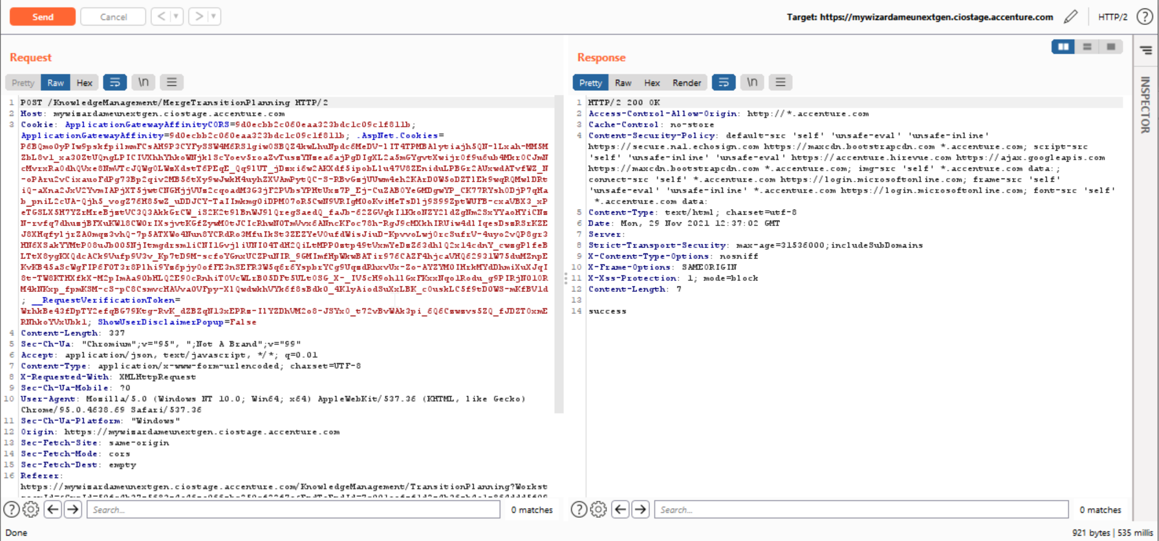

Change the token of admin role to viewer role token and send the request.

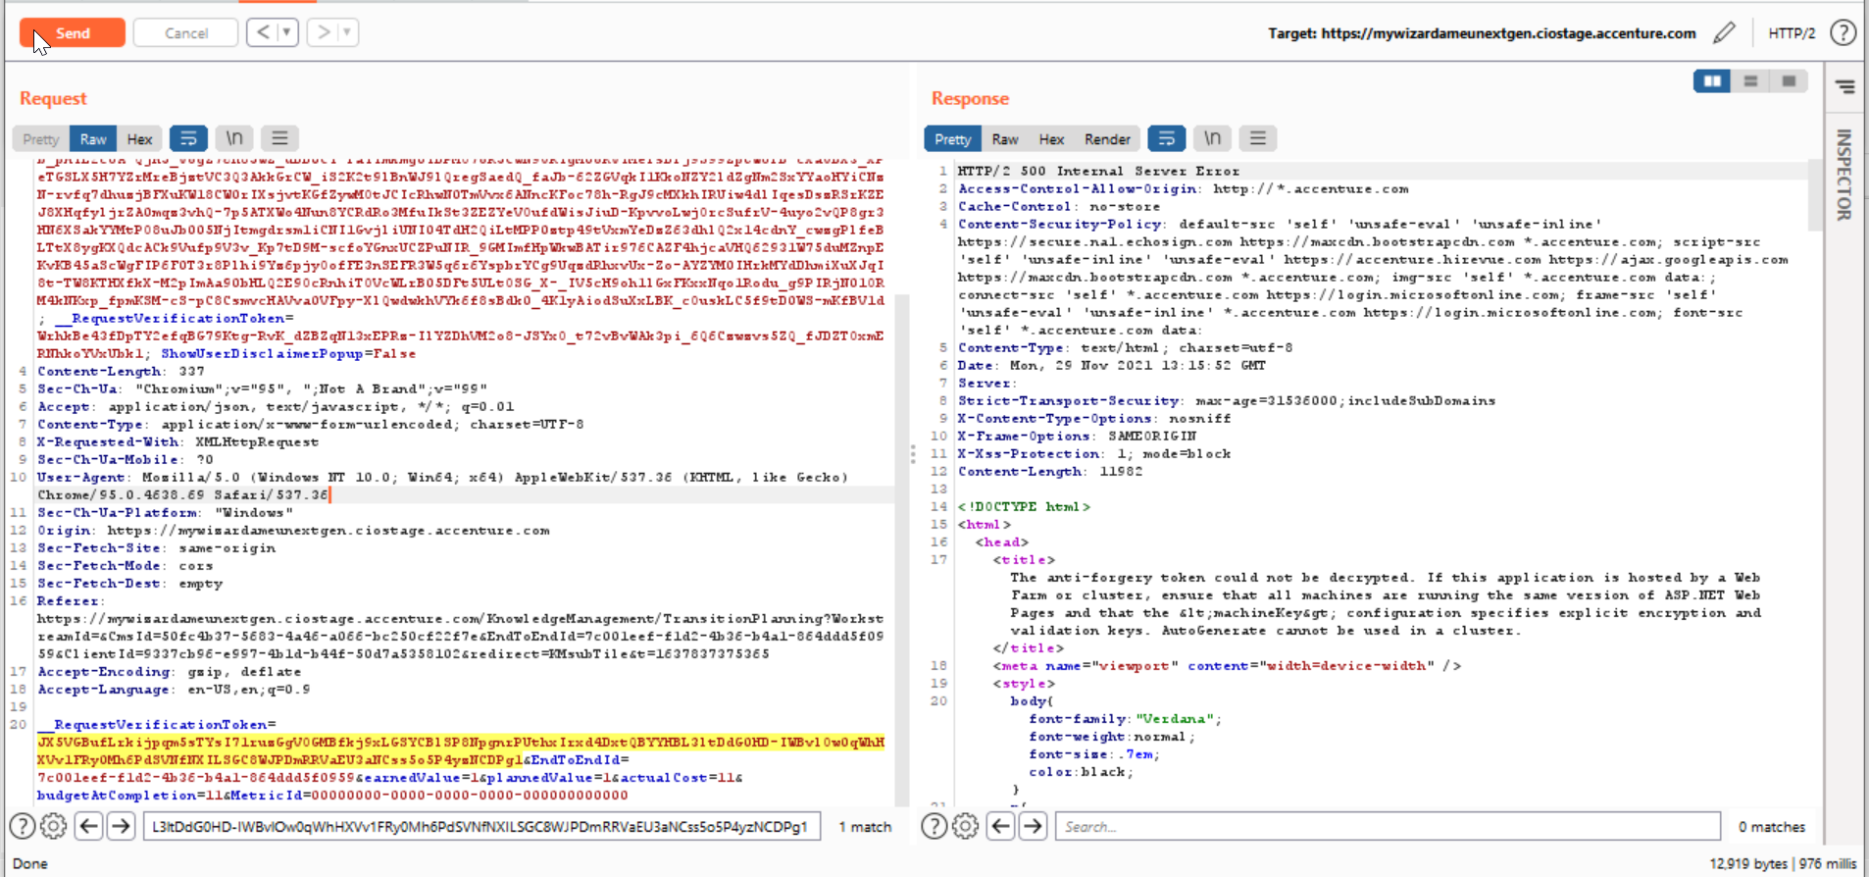

## Testing for Insecure Direct Object References:

No parameters are passed in the URL of Get, Post methods

## Additional Testing for Privilege Escalation:

Not Applicable. SSO is configured

## Testing for Path Traversal:

Capture the request in burp and send it to intruder.

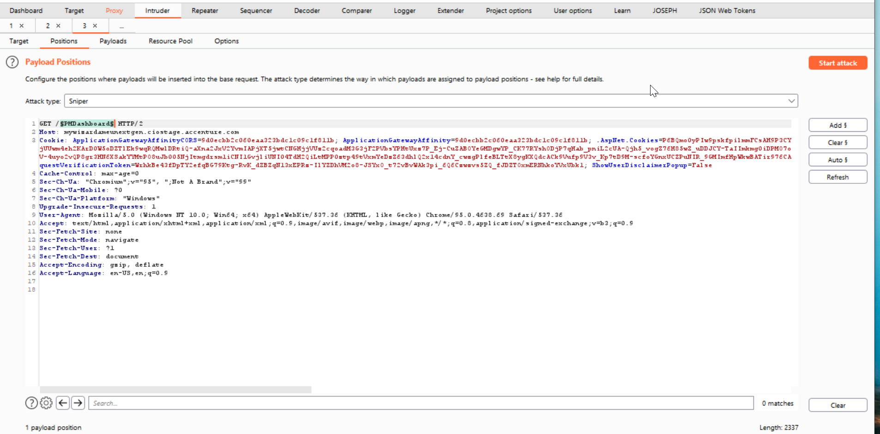

Load the path traversal payloads.

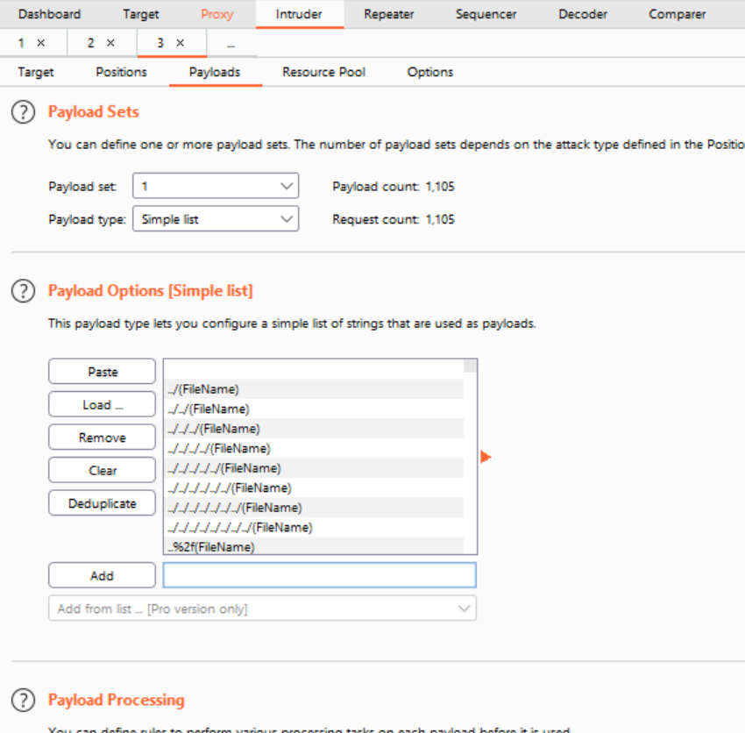

Start the attack and check for the 200 response.

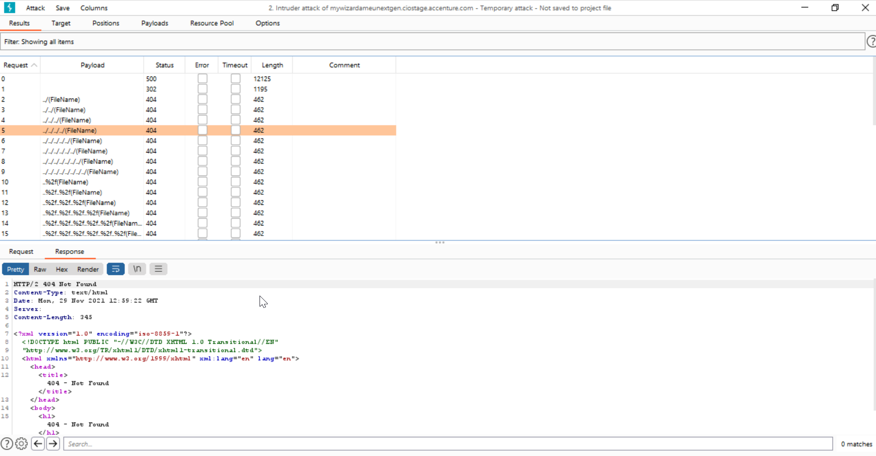

Not a finding

## Directory Listing (Hidden Directories):

Capture the request in burp and send it to intruder.



Load the directory listing payloads. Start the attack.

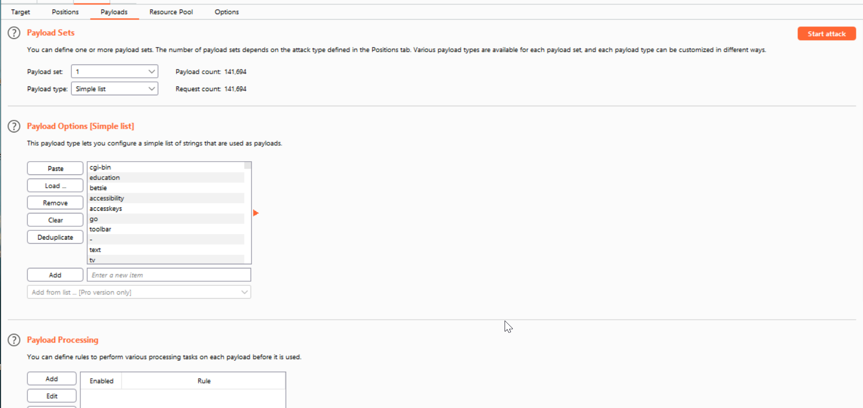

Check the response and look for different response.

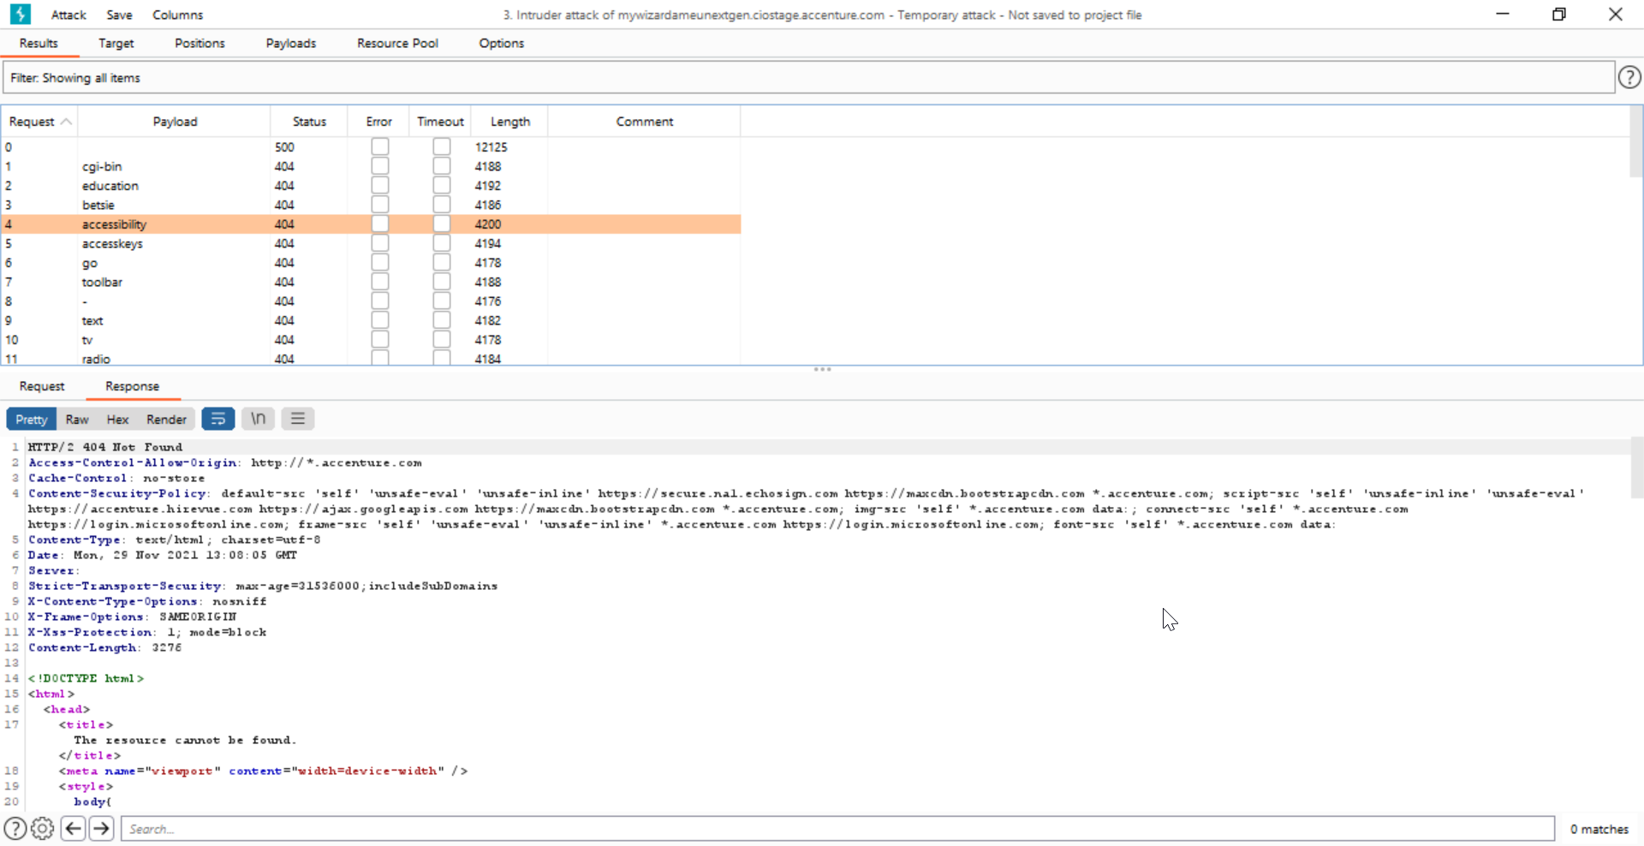

## Authorization bypass thru Chrome Breakpoints

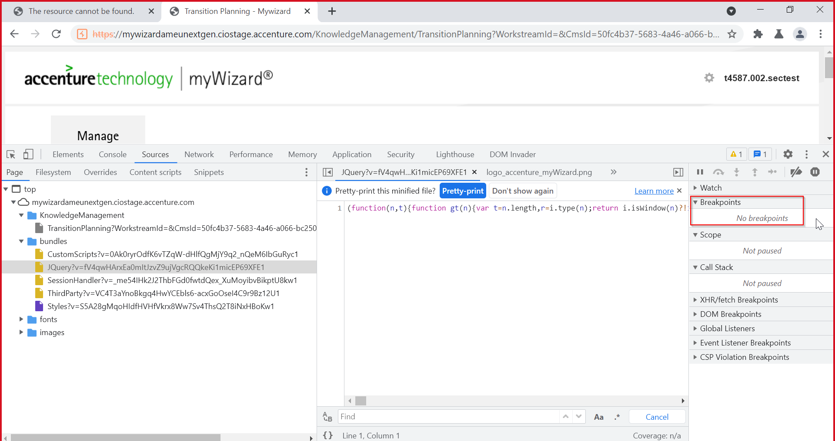

## Test number of times function can be used limits:

NA. No limits are set for the functions.

# **File upload:**

## ​Testing for File Extensions Handling:

Not applicable. File upload functionality is not available in the application.

## Testing for Unauthenticated Access to Uploaded Files:

Not applicable. File upload functionality is not available in the application.

## Test for Unrestricted File Size:

Not applicable. File upload functionality is not available in the application.

## Test for Anti-virus Scanning of Uploaded File:

Not applicable. File upload functionality is not available in the application.

## Macro_CSV Injection:

Not applicable. File upload functionality is not available in the application.

## Secure File Transfer:

Not applicable. File upload functionality is not available in the application.

# Sensitive Information:

## Old, backup and unreferenced files (spidering with authentication):

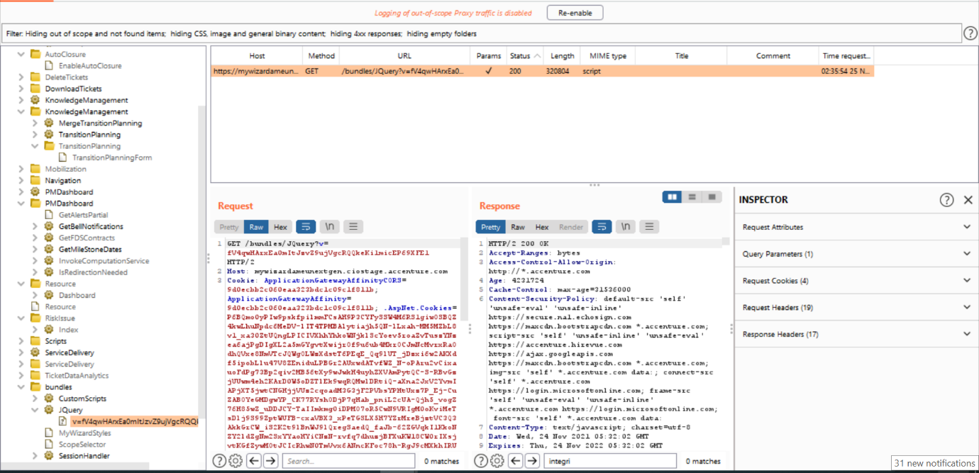

we didn’t find any backup files & unreferenced file in the application.

## Detection of other files for sensitive data or broken authentication:



No sensitive data found.

## Testing for Shared folders in Servers

Not applicable for the vendor application.

## Information Exposure - Query Strings in URL

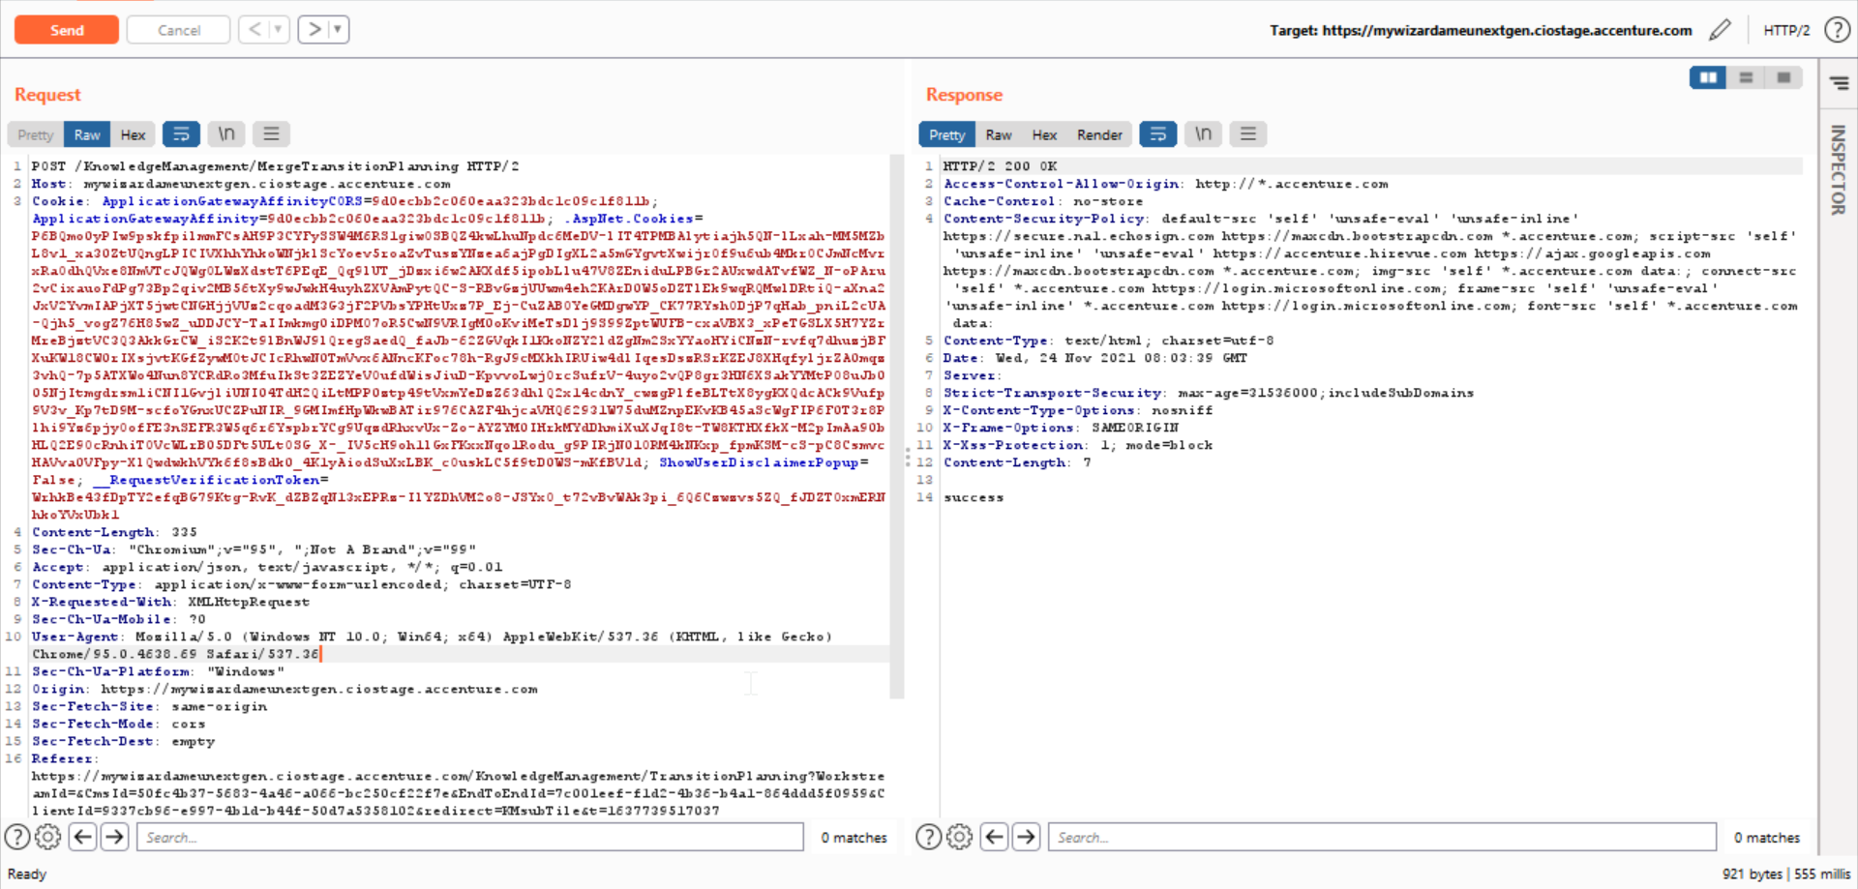

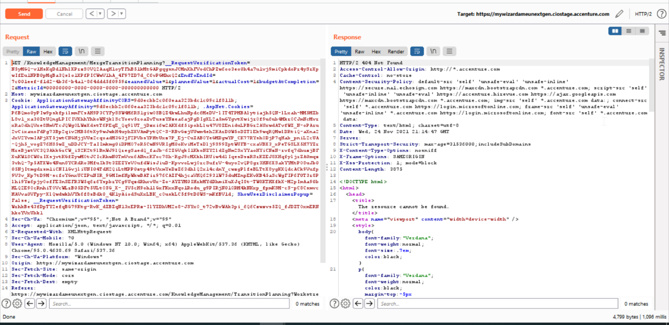

Not getting valid response by changing POST to GET. No sensitive data found

## Look for sensitive information in client-side code like js files

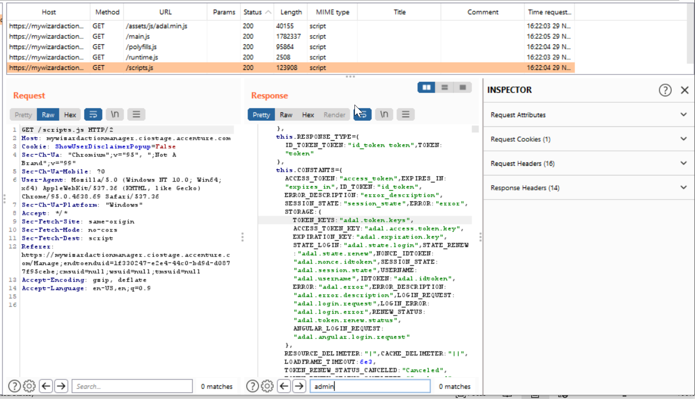

No sensitive details found, not a finding

# **Input Validation:**

## Testing for Reflected Cross Site Scripting (Disabled XSS filter):

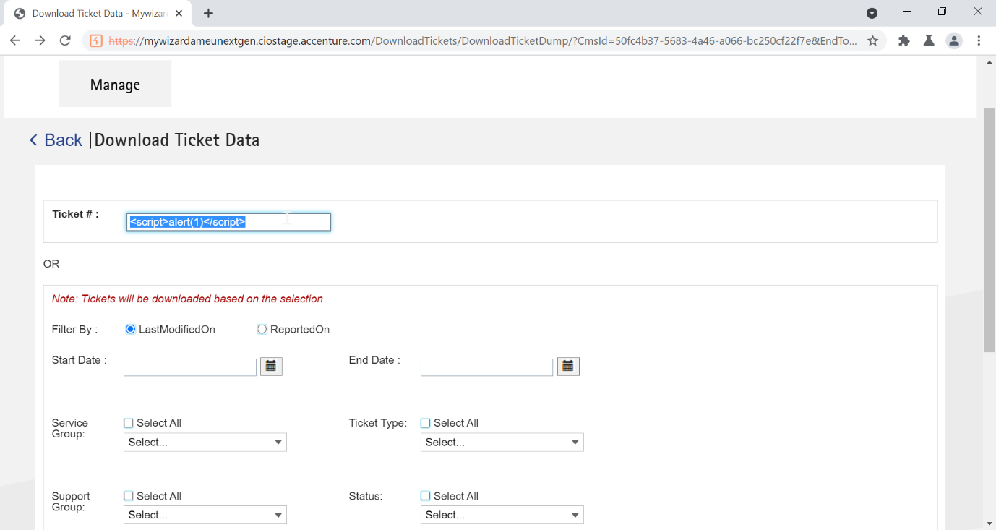

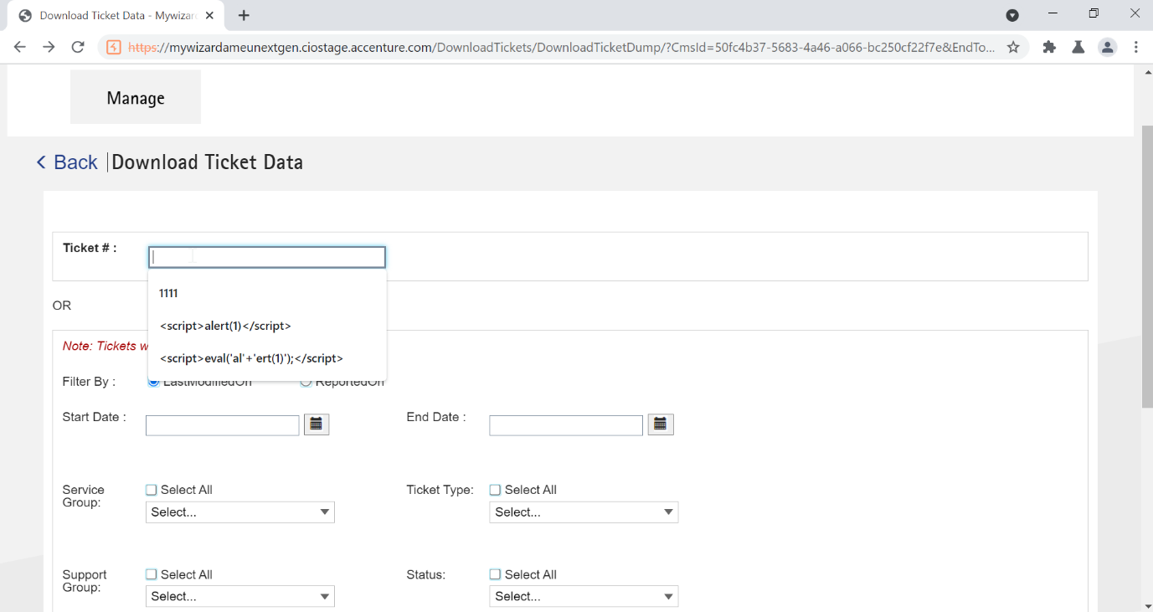

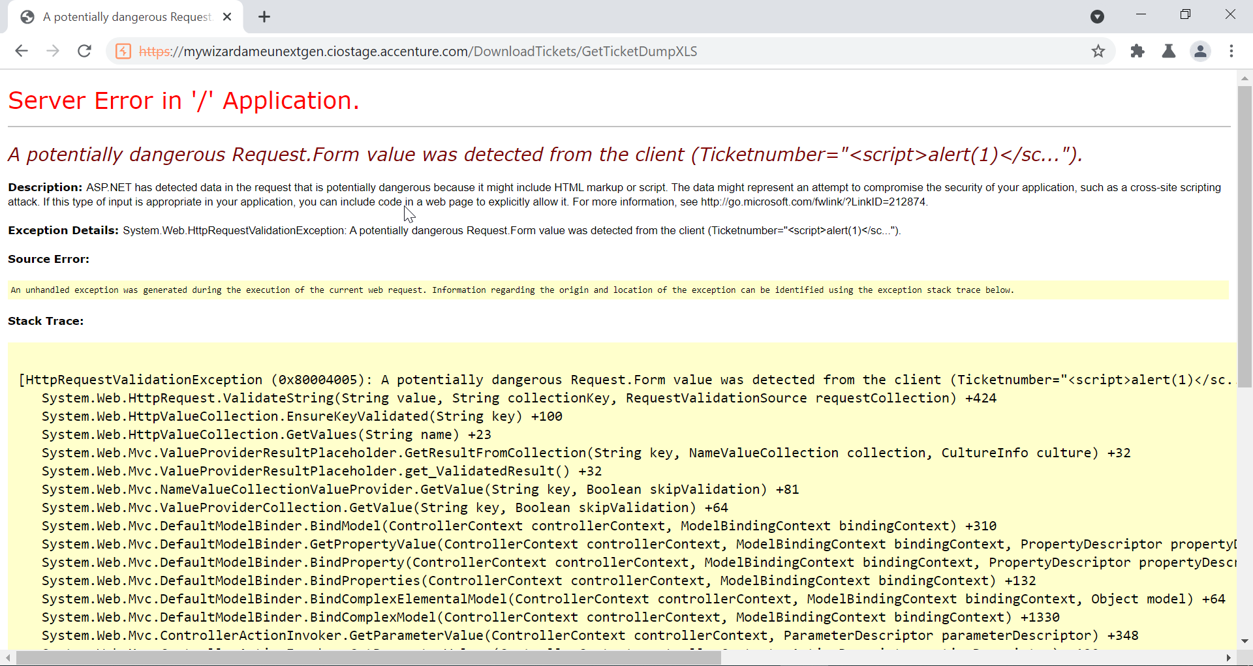

Getting server Error showing Stack Trace error in responses

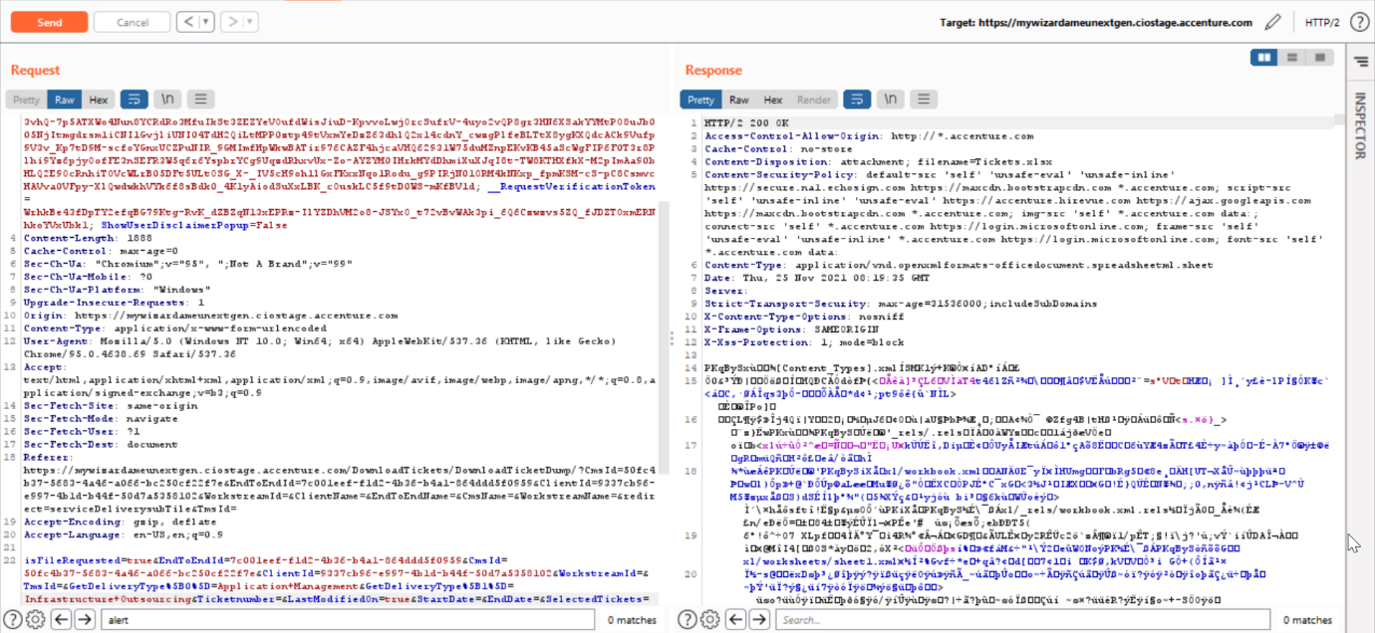

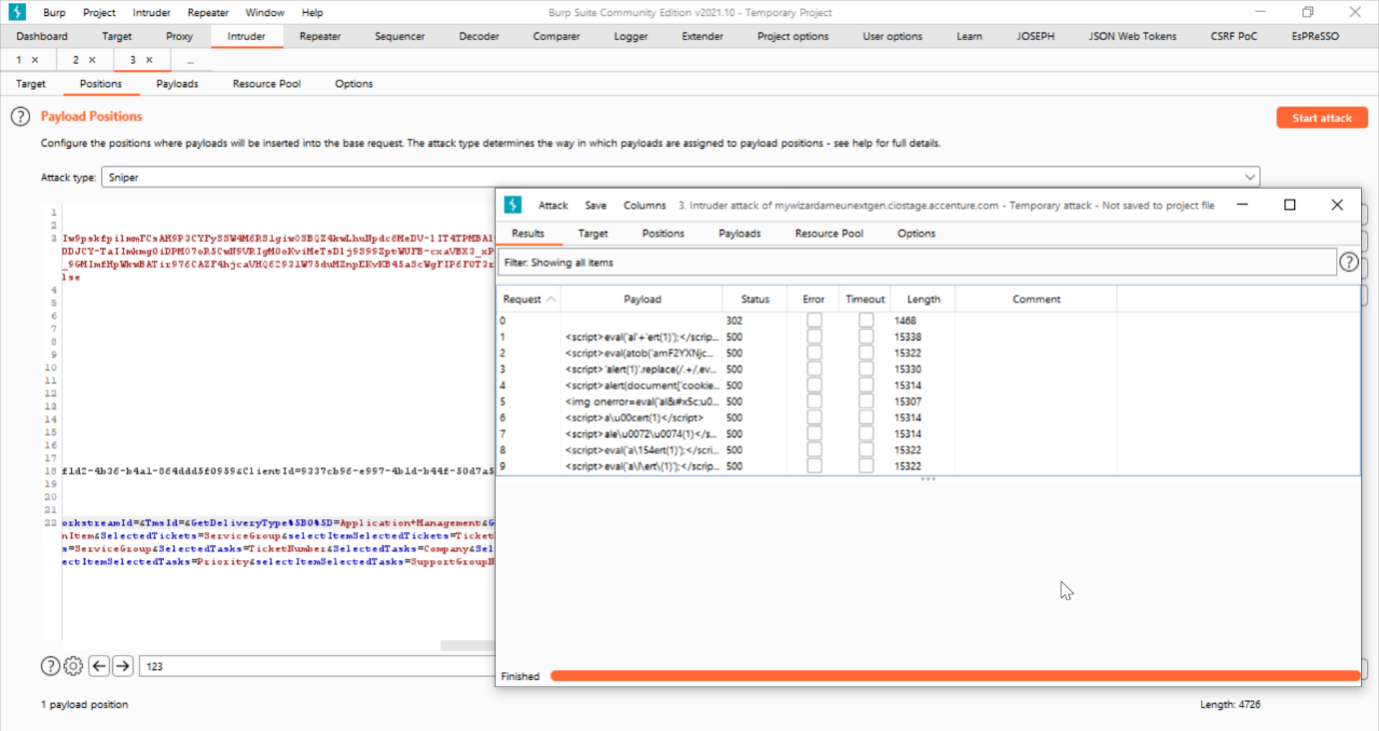

Intercepted a search field and passed the xss payloads, Getting server Error showing Stack Trace error in responses.

## Testing for Stored Cross Site Scripting:

Poor input validation, all the special characters are being allowed into the section.



## Testing for DOM based Cross Site Scripting - DOM XSS:

Not applicable, Out of scope.

## Testing for Cross Site Flashing:

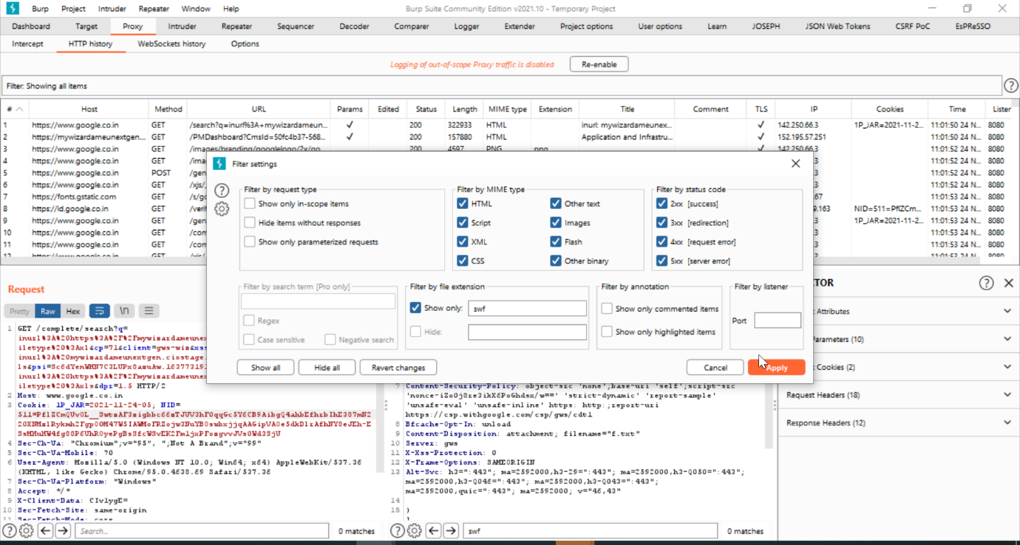

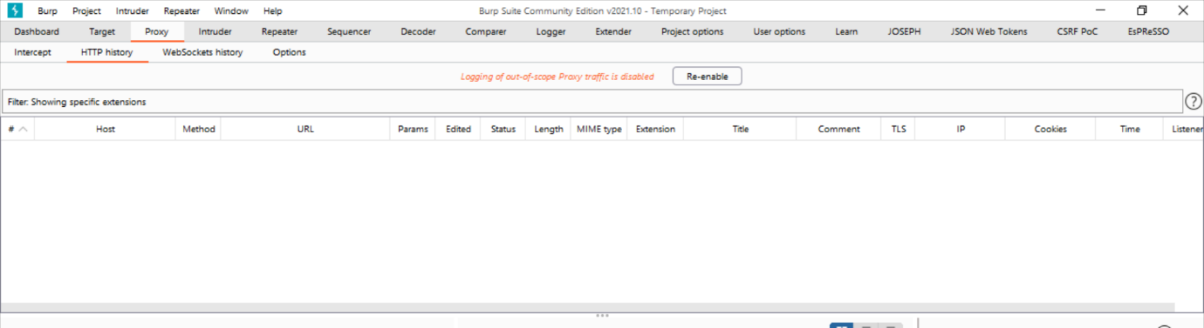

No SWF files are found

## SQL Injection:

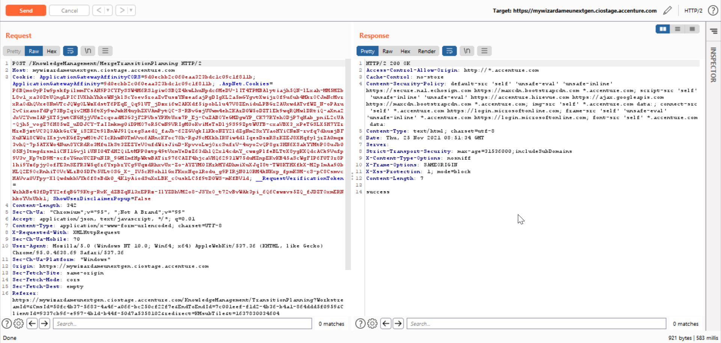

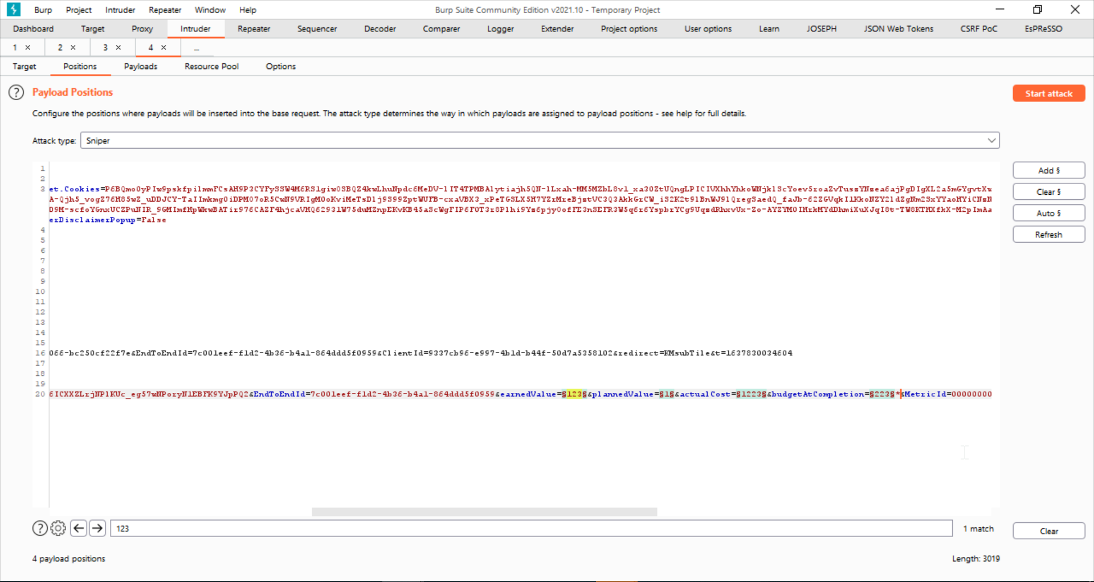

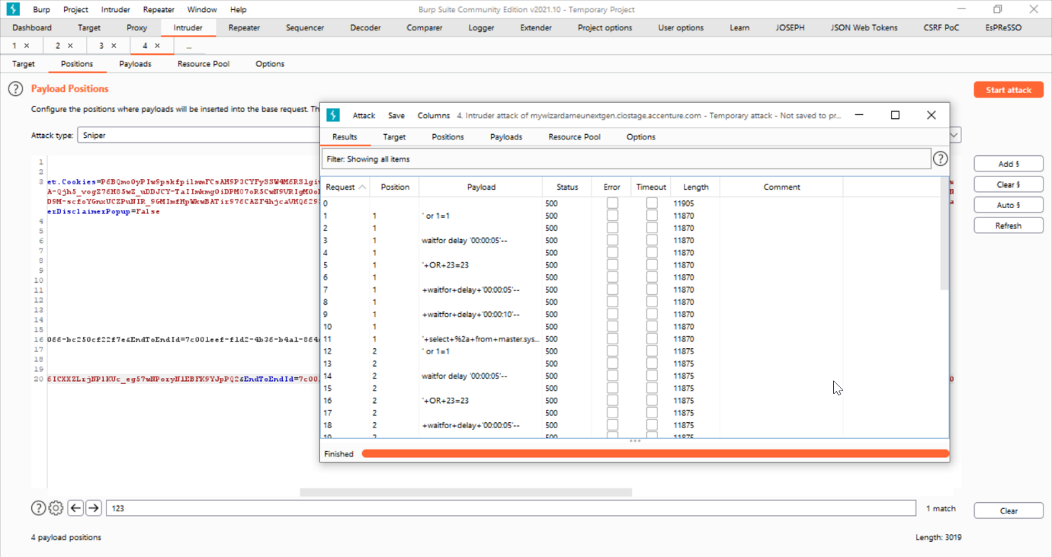

Giving 500 Internal server error for payloads.

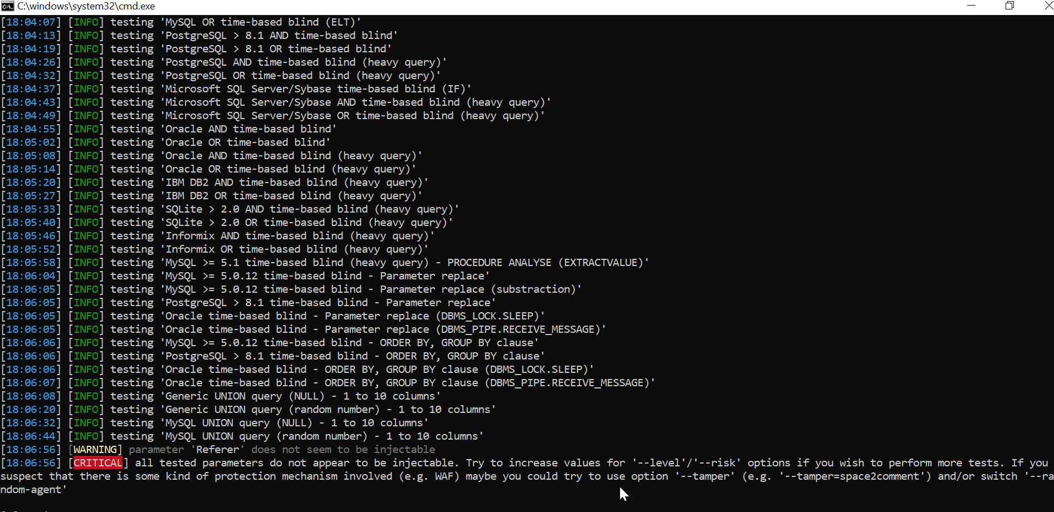

## Test for Unvalidated Redirects and Forwards:



Redirection not possible for this application.

## [XML Injection](https://ts.accenture.com/Sites/CIOSecurityAudit/CIO%20Security%20Assurance%20and%20Compliance/Tools%20Initiative/ToolsWiki/Manual%20Test%20Procedures/XML%20Injection.aspx):

Converting A JSON file to xml and sent the request:

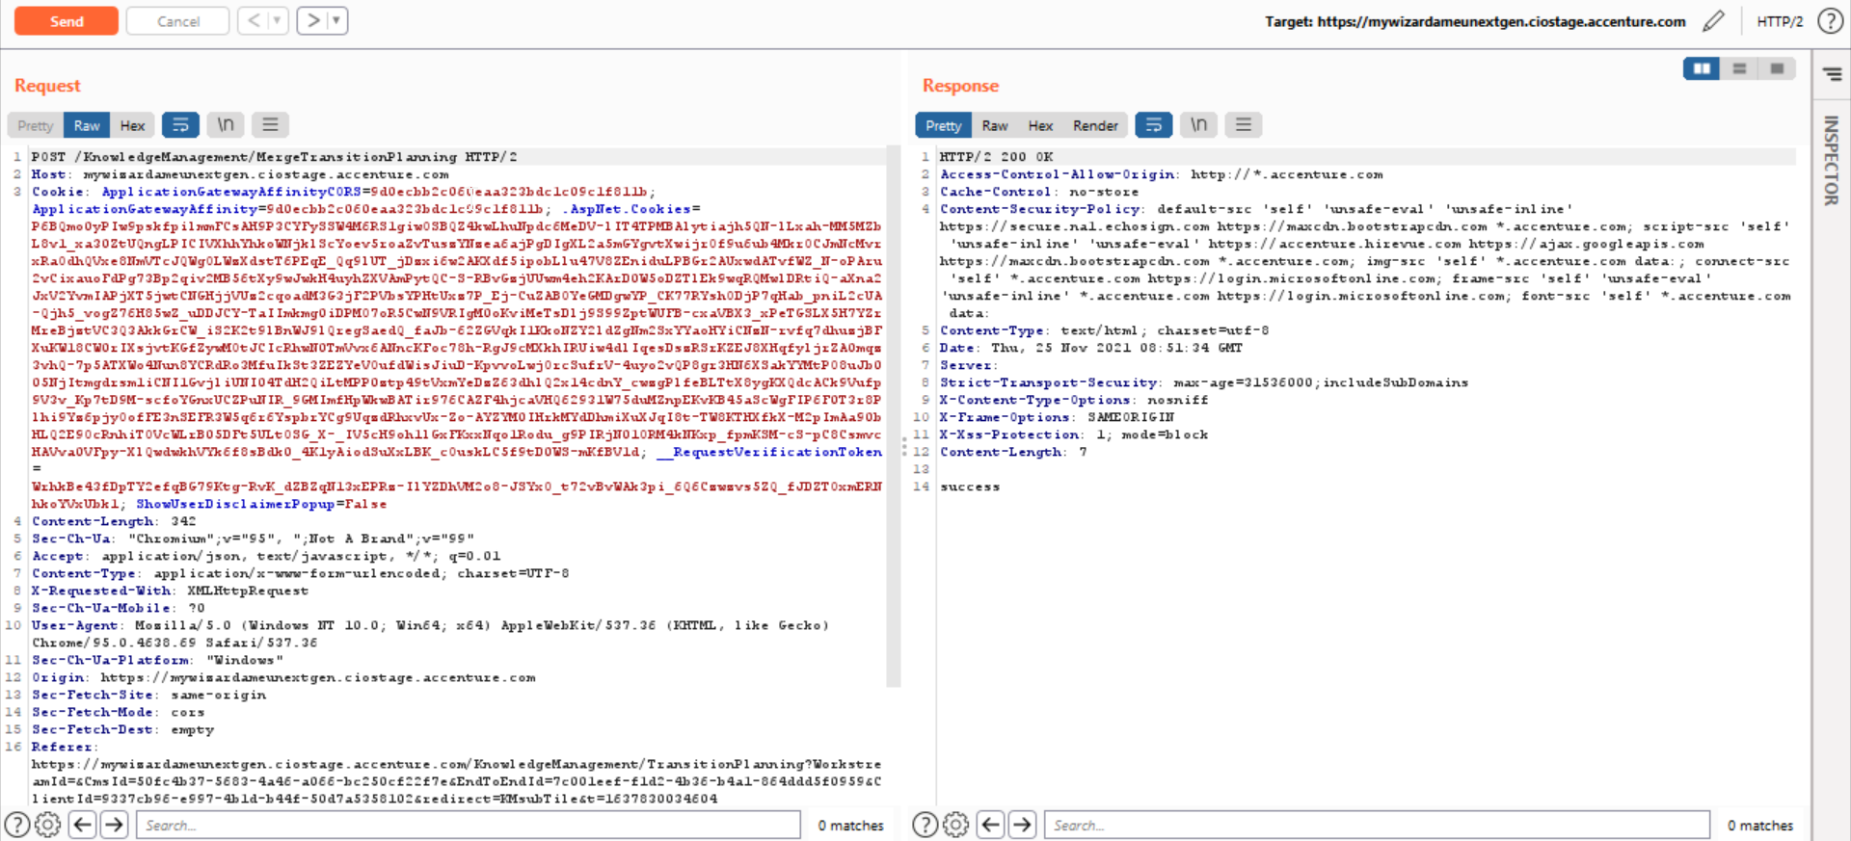

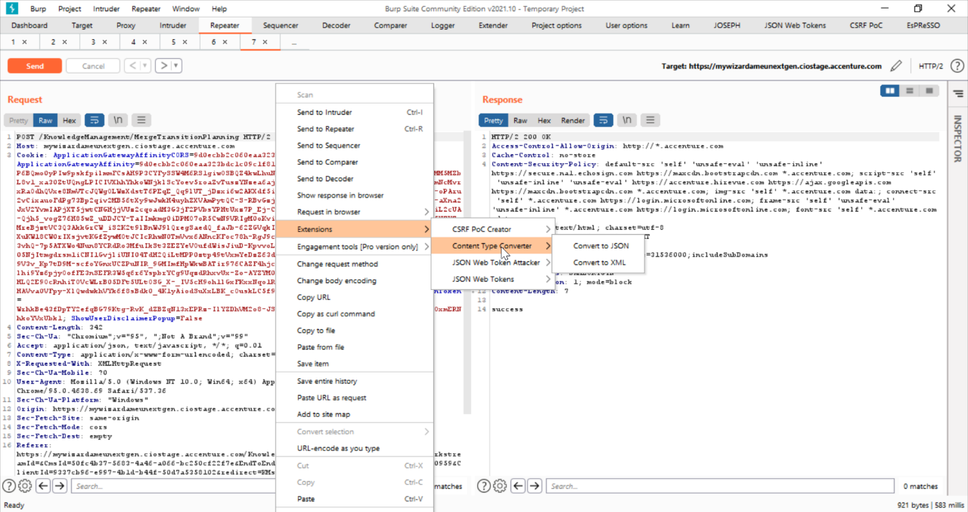

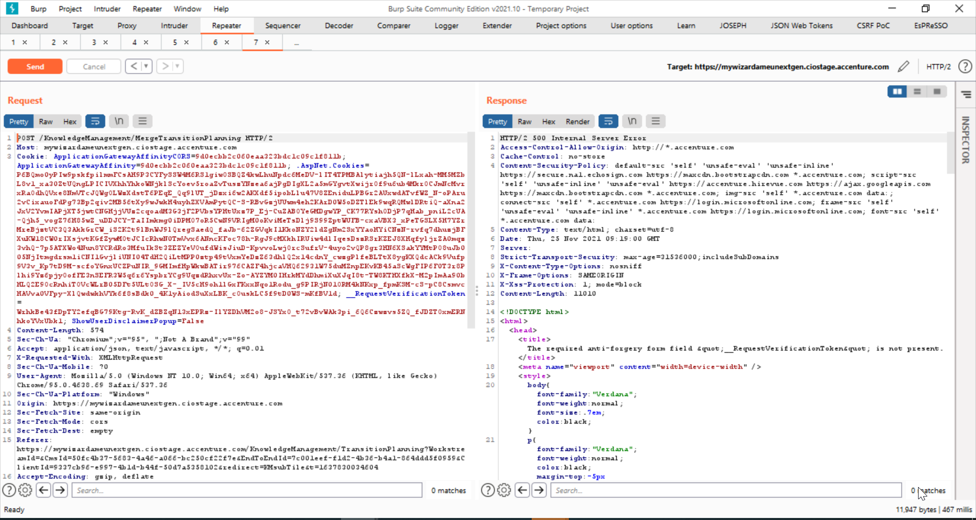

## Host Header Injection:

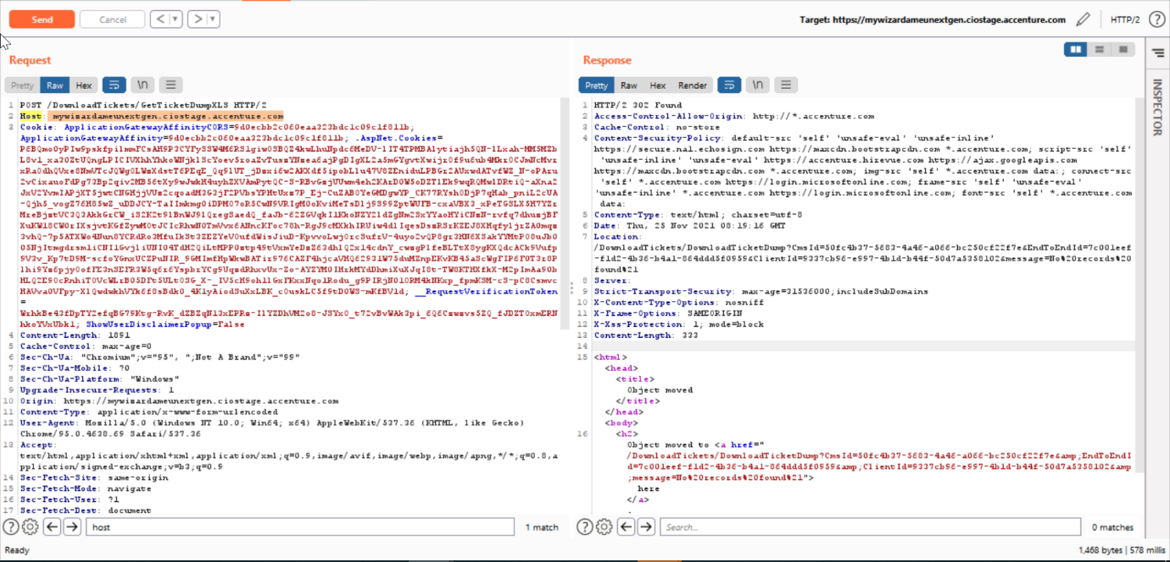

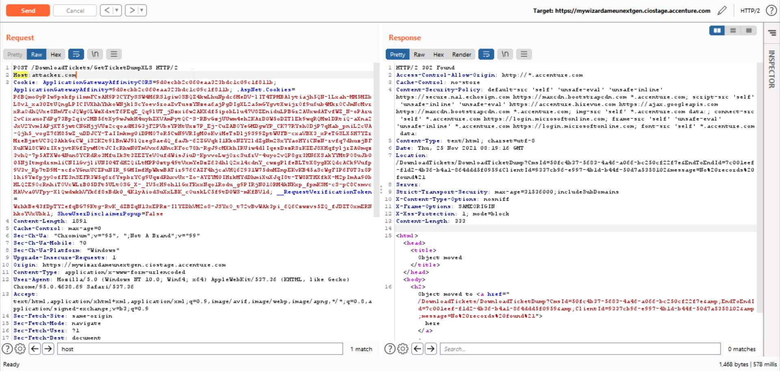

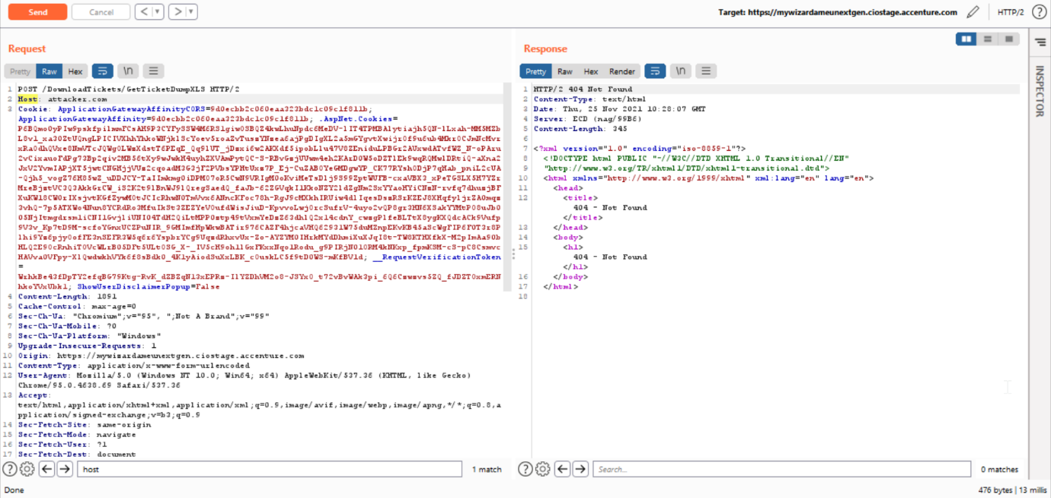

Not possible

## Content Spoofing:

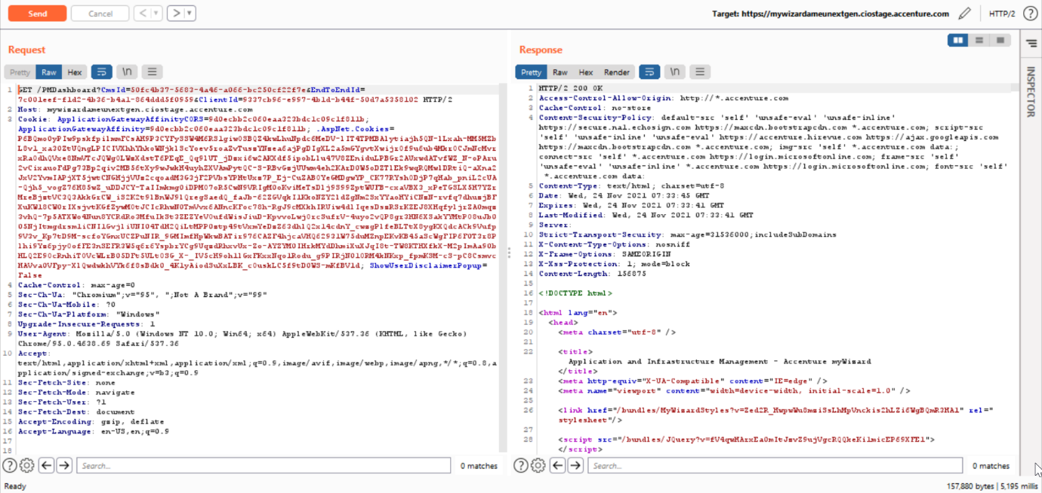

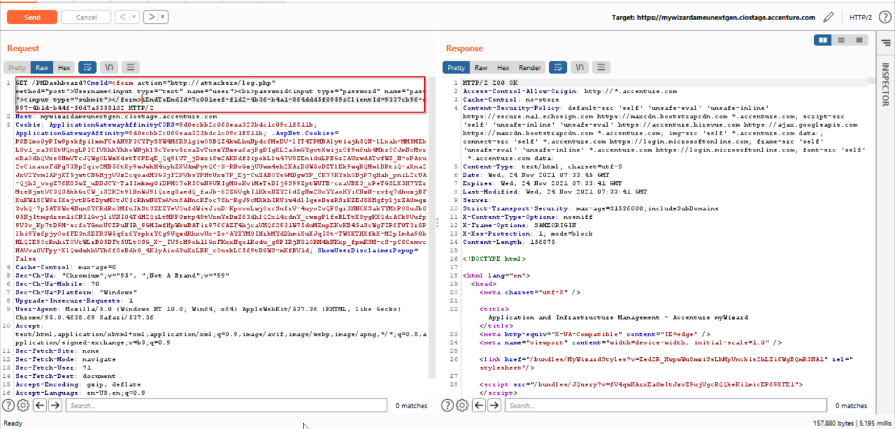

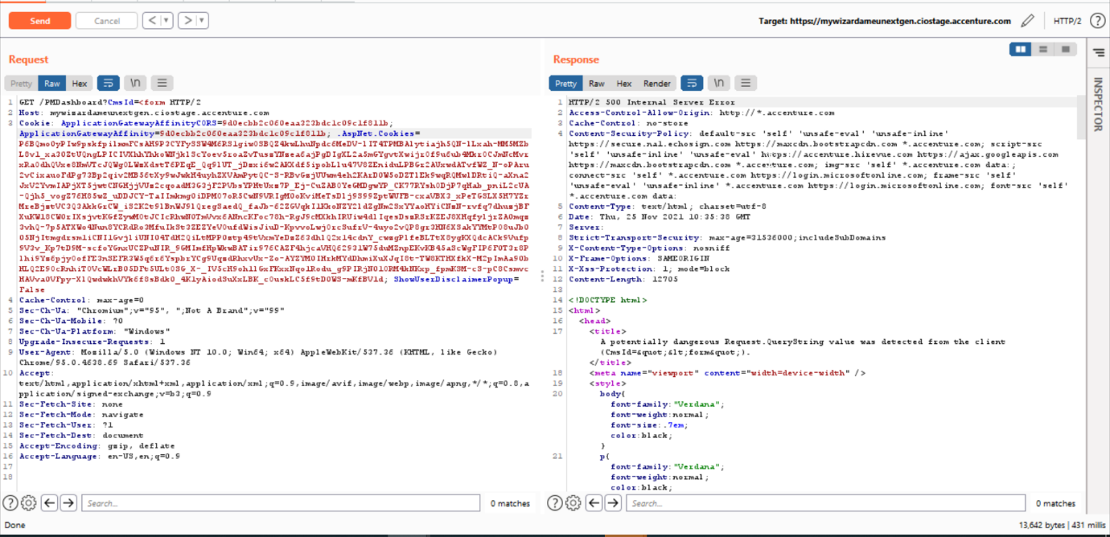

Getting Server Error

# **Denial of Service Testing:**

## ​Testing for DoS Buffer Overflows:

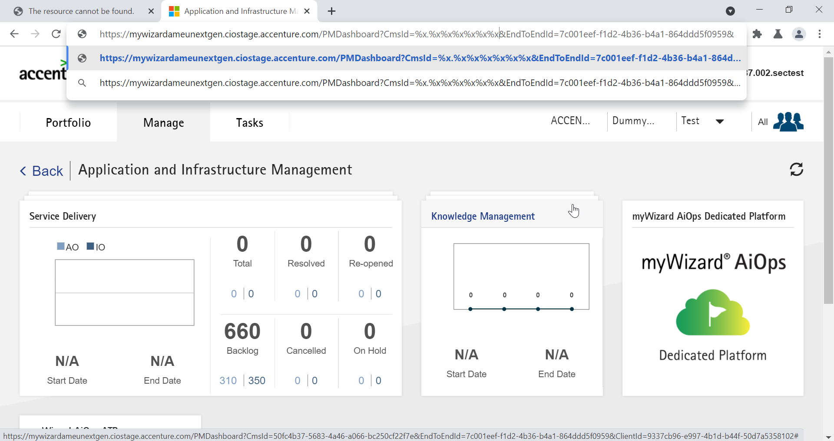

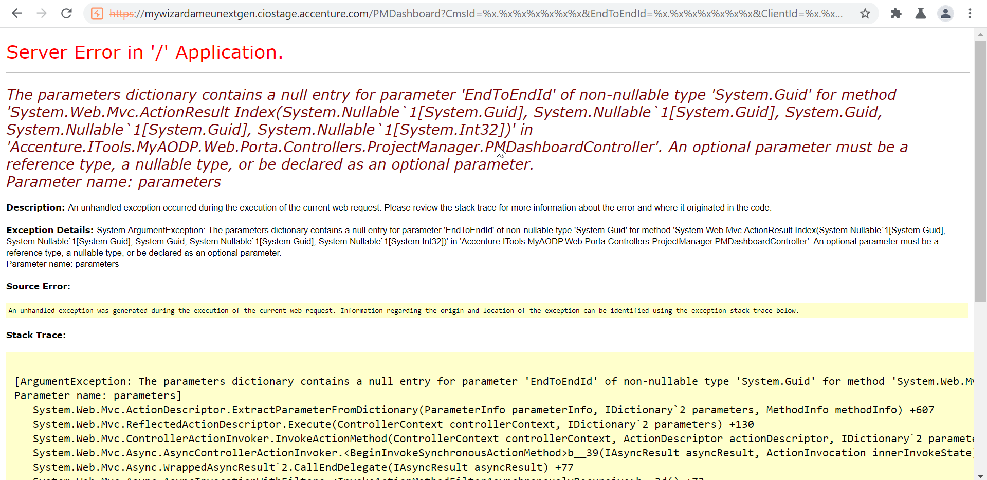

Getting Server error

## Test for Unrestricted Field Length:

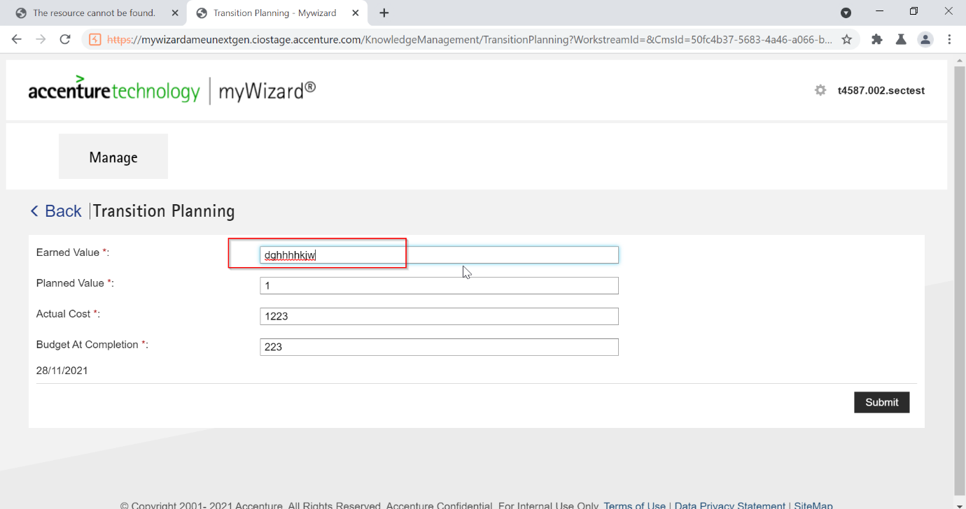

Field length is already restricted in the application.

## Test for Automated Form submission attacks:

NA.

## Captcha bypass and replay attack:

No captcha-based authentication is implied/available in the application.